Retour d’expérience
de ma mobilité internationale
Jules Trubuil – jules.trubuil@gmail.com

[FINLAND] – [laurea]
Agenda
I. Your overall feeling after your semester abroad 2
II. Before the travel 2
A. Preparation 2
1. Visa 2
2. The flight 2
3. My luggage 2
4. Bank account 2
5. Insurance 2
B. Housing 2
1. Where to live 2
2. Find a flat or a room 3
3. Cost 3
III. When I arrive at the university 3
A. Inscription at the university 3
B. Information on the university 3
1. Class 3
2. Organization of the Class 3
3. List of courses and recommendation 3
4. Exam 3
IV. When I life there 3
A. Safety 3
B. Phone and Internet 4
C. Events 4
D. Sports 4
E. Eating 4
F. Go to the university : bus, car, bike 4
G. Travels 4
H. Any other information you would have liked to know about 4
V. After your semester abroad 4
A. What are you planning do to? 4
B. In which master was you accepted 4

Your overall feeling after your semester abroad

My overall experience was positive, and if I had to do it all over again I would do it again without hesitation. Finland is a truly magnificent country and I recommend exploring as much as possible. What's more, on paper the destination is “Vantaa”, but in fact our life as a student is organised in Helsinki, as the university is a maximum of 30 minutes away by train, so it's great to have been able to live in a capital city.
However, there were a lot of things I didn't like about the way the courses were organised. There were far too many distance learning courses, creating a frustrating feeling of not being able to meet other Finnish or foreign students.

GRADE : 4
=> 0 (I do not recommend this semester abroad to my best friend) – 5 (I totally recommend this semester to my best friend)

Before the travel

Preparation

Visa
No, you don't need a visa because Finland is in Europe.

The flight
For the outward journey I took a flight from Paris to Helsinki on Finnair, which I had to take at the end of November for a departure on 4 January. The ticket cost €180. For the return journey I took a Norvegian Airlines flight from Helsinki to Nice, I booked it at the end of March for a departure on 26 May, the price was €150.

My luggage

I took a 23kg hold suitcase, a cabin suitcase and a rucksack. Don't forget your passport and identity papers, of course, but if you're going to Helsinki, I'd recommend having some clothes for the cold, especially if you're planning to go to Lapland. HOWEVER, in Finland there are some great cold stores that are very present in the cities, called UFF. You can find all kinds of clothes for very low prices.

Bank account
Yes, I've created an account with the online bank Revolut so that I can make as many transactions as possible for €0 in fees. My initial bank, La Caisse d'Epargne, charges €8 per foreign transaction.

Insurance
I have not taken out insurance.

Housing

Where to live
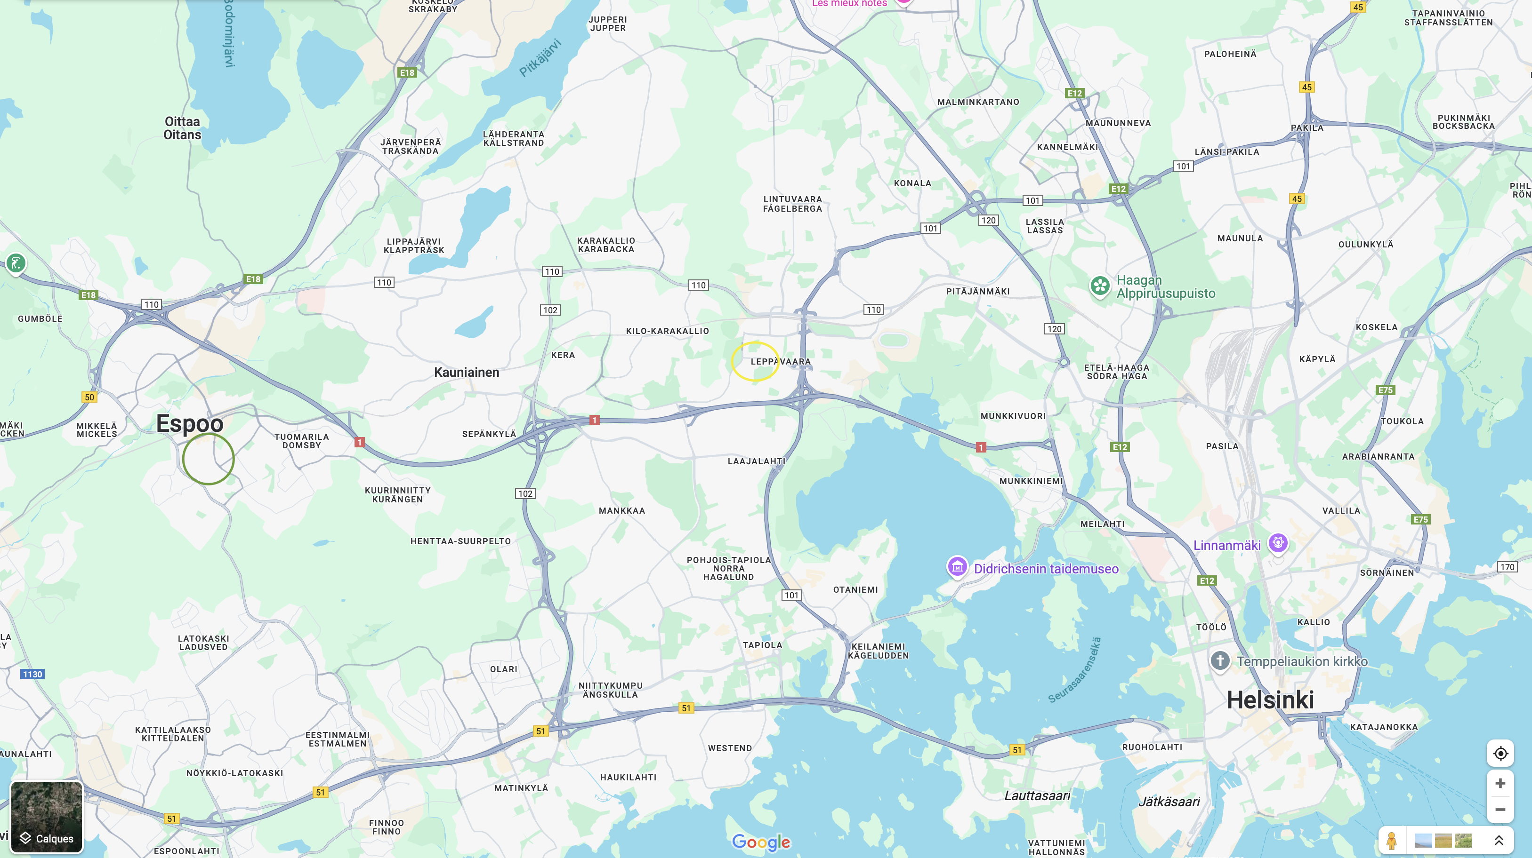
I used to live in the centre of Espoo here circled in green, the university is in the place circled in yellow in Leppavaara. If you can afford a slightly more expensive rent, I'd advise you to live in Helsinki itself, in the Pasila district to be precise. However, I'd also recommend Espoo, because even though it's a 30-minute train ride from the university and 40 minutes from Helsinki, the town is very residential and pleasant. You can also live in Leppavaara if you want to be close to the university, which is also very pleasant and well placed.

Find a flat or a room
I lived with 2 other people in a shared HOAS flat. It's the equivalent of CROUS in France, you have to apply as early as possible and then the HOAS foundation makes you a one-off offer that you either accept or refuse. I recommend using HOAS, if you go for the spring semester, rental for the month of June is free.

Cost
For the 18 m2 room in my 80 m2 flat, I paid 509€ per month, which is not expensive compared to the price in Helsinki itself.

When I arrive at the university

Inscription at the university
It's easy to enrol at university, but once you're there you need to go to the Finnish registration office to register and obtain a Finnish number.

Information on the university

Class

On the negative side, we did not have a choice of courses, as the ‘Business Management’ pathway was only accessible via these four courses:

- Service Design: I don't recommend it, to put it simply it's a course to learn how to work in a group. Much too theoretical. What's more, the groups are random and, in my case, working with the Finns was not pleasant.

- Data Driven: Nice course based on a business simulation game, you can choose the groups. I would recommend.

- Corporate Social Responsibility: Teaching without course sessions, whether distance or face-to-face, we have to learn knowledge and do quizzes... This type of course is very unpleasant for an exchange student because we have no contact with anyone to finish the course.

- Digital Marketing: This is a very practical course where the groups have to carry out practical tasks for a company. It's a great way to build relationships, and I'd recommend it.

Organization of the Class
I was very disappointed with the way the courses were organised, they don't seem to have evolved since covid, only online courses and only two subjects that require you to go to the college. And if I count the number of times I've been there, it's no more than once a week. Also, not all the courses are at the same time, they're spread out over the whole semester, so overall the workload is very light. That's not necessarily positive, because I feel that I've achieved very little at the end of the semester... However, the teachers are friendly and approachable. The school is very well organised in the first sense, the timetables are clear and so are the deadlines for assignments.

List of courses and recommendation
I think I answered that in the previous section.

Exam
I would say that the examination system is very different from MOMA, it's not based on midterms. Also the marks are very generous, I got excellent results whereas at MOMA I was just average.

When I life there

Safety
Finland must be one of the safest countries in the world, so don't worry.

Phone and Internet
Even in the snowy desert you can pick up 5G with all the bars, it's pretty impressive. I had to take out a Finnish package in May because my French operator, SFR, cut the line after 3/4 months abroad.

Events
Follow the Instagram accounts of Laurea's student organisations or, more generally, the erasmus accounts in Helsinki. You can download “Kide” as well.

Sports
It's impressive to see that Finland has pitches for all kinds of sports everywhere, but there are no student associations to promote sport. Also, it's a bit hard to go outside to play sport in winter, but as soon as spring arrives, all the locals are outside.

Eating
I strongly recommend that you eat as much as possible at the university restaurants, which are very good and cheaper than in France. However, they are only open in the evening in Helsinki itself.

Go to the university : bus, car, bike
The transport network is exceptional down there, bus, train, tram, metro... pass frequently everywhere. Personally, I used to take the train to go to school.

Travels
If you get the chance to do just one trip, do Lapland, I was reluctant at first but it was really great. What's more, lots of student organisations offer trips that include accommodation, transport and activities. The price is very, very reasonable for such a trip; if you want to do it independently, it's more expensive. It's now or never.
Otherwise, you'll see that the Finns go to Tallin in Estonia a lot, the travel is cheap and the food and alcohol is cheaper. I recommend spending a day or 2 days maximum there.
Also, if geopolitical conditions allow, I'd advise you to go to St Petersburg. I didn't do it, but I'm sorry I couldn’t.

Any other information you would have liked to know about

Not necessarily information, but just to say how magnificent this country is and I recommend going there. It's a real experience.

After your semester abroad

What are you planning do to?
Next year, I'll be studying philosophy in my first year.

Did you apply for master?
Yes, I applied for 7 masters courses, but unfortunately I was turned down for all of them. After that, I'm not complaining, because during my three years of study I didn't get good enough marks for the masters I applied for.

[remember to fill in the excel : https://docs.google.com/spreadsheets/d/11-vB4ABdkzIJR1AQ82drWyAVXfnCpRYr8COkeKihnIs/edit?usp=sharing]

To update the agenda just click right on your moose

