Retour d’expérience
de ma mobilité internationale
Anaïs BROCHEC – anaisbrochec@yahoo.fr

SWEDEN – Södertörns Högskola
Agenda
I. Your overall feeling after your semester abroad 2
II. Before the travel 2
A. Preparation 2
1. Visa 2
2. The flight 2
3. My luggage 2
4. Bank account 2
5. Insurance 3
B. Housing 3
1. Where to live 3
2. Find a flat or a room 3
3. Cost 4
III. When I arrive at the university 4
A. Inscription at the university 4
B. Information on the university 4
1. Class 4
2. Organization of the Class 5
3. List of courses and recommendation 6
4. Exam 6
IV. When I life there 6
A. Safety 6
B. Phone and Internet 6
C. Events 6
D. Sports 7
E. Eating 7
F. Go to the university : bus, car, bike 7
G. Travels 7
H. Any other information you would have liked to know about 7
V. After your semester abroad 7
A. What are you planning do to? 7
B. In which master was you accepted 8

Your overall feeling after your semester abroad

My experience was rather okay — not amazing, but not bad either. That’s partly my own fault. If you're sociable and not too much of a homebody, things should go well for you.
The university is nice!

GRADE : 3
=> 0 (I do not recommend this semester abroad to my best friend) – 5 (I totally recommend this semester to my best friend)

Before the travel

Preparation

Visa

No visa is required for French citizens.

The flight

I flew with SAS, which lands directly at Arlanda Airport. From there, the Arlanda Express offers a direct connection from the airport to the center of Stockholm.
I booked my ticket in October and traveled with two large suitcases (which I wouldn’t recommend). Because of that, my tickets were a bit expensive.

My luggage

The essentials I packed included thermal ski underwear (long-sleeved top and leggings), which was enough to keep me warm during the cold months, along with a ski jacket and boots for the first few weeks.
However, don’t pack only winter clothes — spring does arrive eventually, so bring lighter clothing as well.
I also recommend bringing at least one set of bedding for your first night. After that, it’s easy and affordable to get the rest at IKEA.
If you’re arriving in January with large suitcases — stay strong! The sidewalks are covered with gravel to prevent slipping, but it makes rolling your luggage pretty difficult.

Bank account

I’m with BNP Paribas and mostly used my French bank card while in Sweden, with the “Travel” option (€5 per month) to reduce transaction fees. It didn’t eliminate the fees entirely, which was a bit frustrating.
Using a neo-bank like N26 or Revolut might be a good alternative. That said, traditional banks can work too — just make sure to schedule a meeting with your advisor beforehand to ensure everything is set up correctly for international use.

Insurance

I initially panicked about housing insurance, since the lease explicitly mentioned that it was mandatory. But in reality, no one ever asked me for it once I arrived.
I went with MAIF because they offer coverage for international stays during Erasmus — a good option if you’re feeling anxious about it. That said, it’s likely you’ll be fine even without it.
As for health insurance, I applied for the European Health Insurance Card (EHIC) on Ameli. The process is quick, but make sure to request it early enough to receive the physical card in time.
Personally, I forgot and applied just a week before leaving — I didn’t receive the physical version, but I had access to the virtual card through the Ameli app.
If you’re not a French national, there are other options available, but they can be costly — my classmates mentioned prices between €100 and €225.

Housing

Where to live

The university offers two housing options: Flemingberg Center and Björkulla.
If you're sociable and want to avoid feeling isolated, I’d recommend Björkulla. But if you value comfort and personal space, Flemingberg might suit you better — there's a gym nearby, a supermarket literally at the base of the building, and even an Espresso House (similar to Starbucks) not far away. I stayed at Flemingberg and really liked it.
From Flemingberg, it’s a 10-minute walk to the university. From Björkulla, it’s about 20 minutes on foot, though there’s a bus. Be aware that the bus schedule may sometimes cause you to arrive late.

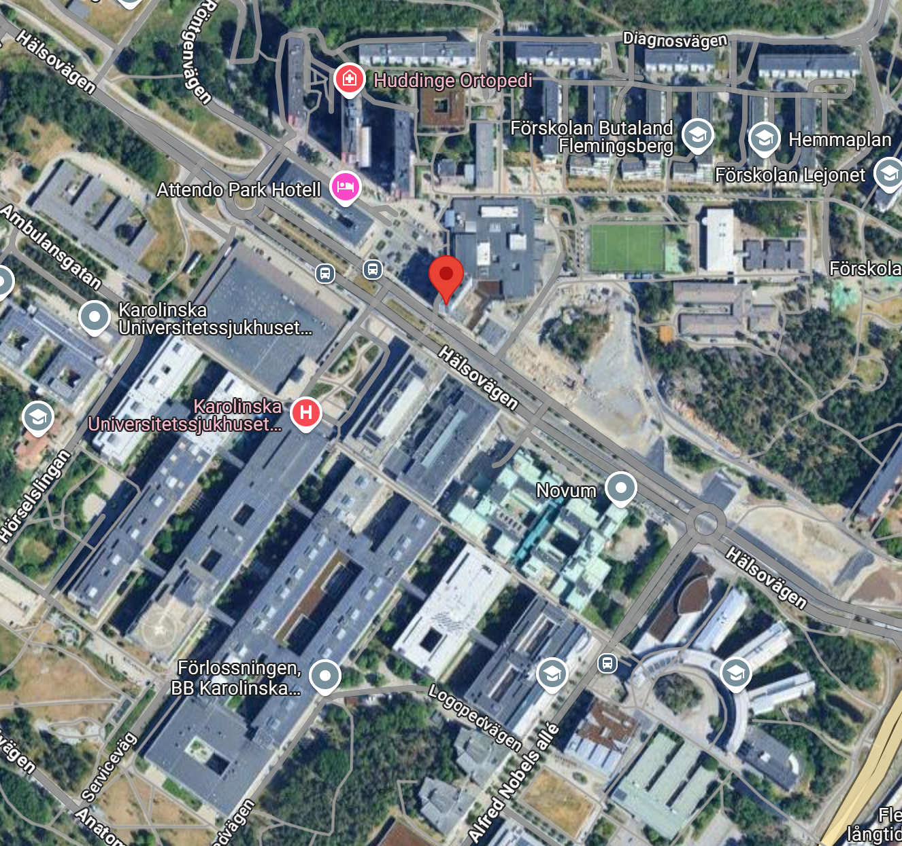

Find a flat or a room

The university will send you an email where you can rank your housing preferences: Björkulla, Flemingberg (private room), or Flemingberg (shared room).
Avoid choosing the shared room at Flemingberg. It’s the same size as the individual room, but shared between two people, with beds placed quite close to each other.
Sure, it’s cheaper — but it comes at the cost of your mental well-being (based on feedback from two Erasmus students).
Unless you're coming with someone you already know and trust (in which case you can request to share the same room), I strongly recommend choosing a private room instead in Flemingberg or Björkulla.

Cost

The total cost of my housing was €3,200. Thanks to the Erasmus and MOMA grants, I managed well financially.
In my case, the grant only arrived at the end of February, so it didn’t help me upfront — it basically acted as a “reimbursement” afterward.

However, be aware that you're required to pay everything in advance — and we're talking about large amounts, so it's important to plan ahead.
I had to pay €1,200 in December and €2,000 in January. You need to have that money available in your account, but once it’s paid, you’re all set for the semester.

When I arrive at the university

Inscription at the university

Super easy — you just have to fill out a form with the courses you want to take. Once you're on site, there’s plenty of guidance and support, so everything goes smoothly!

Information on the university

Class

- International Management
Great professor — he speaks many languages, including French. The course itself is interesting, but the weekly readings can be long (around 3 hours). Each week, we worked on a group presentation based on a case study. For each one, we had to submit a written report of about 10 pages plus an oral presentation. We had around four of these in total.
It was a good course to meet other Erasmus students — there were almost no Swedes in the class. The final exam is a take-home essay. The grading was supposed to be 40% group work and 60% final exam, but honestly, I think it was more like 20/80, given the large differences in grades within groups.
You’ll recognize some familiar concepts from MOMA, so you won’t feel lost.
- International Marketing Strategy
Same professor as the previous course, but this time with a lot more Swedish students. The structure is very similar — weekly case studies and one reading per week. The main difference is that the cases are based on real companies, whereas in the other course, they were more theoretical.
Again, the readings can be a bit long, but since there’s only one per week, it’s manageable.
- Social Economy and Social Enterprise
I really enjoyed this course. You choose a company and analyze it through the lens of social enterprise — which turns out to be a much broader concept than most people think. The final assignment is a 12-page paper. You get some guidance, but overall you have a lot of freedom.
I only attended the first two sessions and then worked on my own. I chose Veja, a hybrid company, while most classmates focused on nonprofits like “Les Restos du Cœur,” so class discussions didn’t really help my topic.
If you like clear rules and structure like in France, you might not enjoy this course. But if you’re more into flexibility and self-directed work, go for it! It’s still quite a lot of work — definitely the course I spent the most time on.
- Understanding Organization
Surprisingly one of my favorite courses (surprising because there’s a lot of reading, and I usually don’t like that). The professor is really kind and engaging. This was the only class I attended fully — partly because it’s made of seminars, but also because it was genuinely interesting.
Before each session, you read a theory and write a short 500-word reflection applying it to a real-life organization — ideally your own experience (e.g., something from university), which makes the work more relatable and easier to grasp.
Each week, students lead the session by presenting the theories and launching class discussions (don’t worry — it’s not graded). The professor acts more like a facilitator, and time flies.
The only graded assignment is a 2,000-word take-home test at the end — much lighter compared to other courses.
Highly recommended! You’ll see concepts you already know, but you come out with a real practical toolbox — a great course to end a management degree.

Organization of the Class

It depends — classes are between 2 to 3 hours long, and you'll have a maximum of 9 hours of class per week. There’s much more independent work than in France. In the end, it’s really about you and your own curiosity.
Seminars (like tutorials or “TDs”) are mandatory — missing them can mean failing the course. Lectures are optional, but I’d recommend going as much as possible since there aren’t that many. Still, skipping a few won’t kill you.
Professors are approachable — you call them by their first name, which can be surprising at first. You can easily talk to them after class, especially Kjell, the professor for the first two courses I mentioned — he’ll definitely speak to you in French; it’s his way of keeping up the language.
Important note: Professors are very vocal about their stance against using ChatGPT — they often consider it plagiarism. But that needs to be nuanced. I think they react this way because most students use it poorly — relying on it to do the entire assignment.
ChatGPT shouldn’t be doing the work for you — it should assist you, help you go faster, or go further. Personally, I used AI tools for 100% of my final assignments and never had any issues.
For example:
- I used NotebookLM to summarize readings and decide if they were worth spending time on.
- I used ChatGPT to brainstorm and rewrite parts of my drafts (I often write in both French and English when I’m short on time, and it helps turn it all into clean English). Of course, I always reviewed and edited the final version myself.
There are many other tips. The bottom line is: you’ll have a lot of written work — it would be a shame not to use these tools. Just take the time to learn how to use them responsibly.

List of courses and recommendations
- International Management: Same level as MOMA
- International Marketing: Same as MOMA
- Social Economy and Social Enterprise: More demanding
- Understanding Organization: Lighter and more accessible
I highly recommend this combination — I think it’s the best course balance for an Erasmus semester.
And best of all: no in-class exams! If that’s not a win, I don’t know what is.
(But if you decide to take International Banking or the Economics courses — do so at your own risk.)

Exam

All of my exams were take-home tests, you often have at least one week to do it.
Grades range from A (highest) to F (fail).

When I life there

Safety

Super safe — I never had any problems.

Phone and Internet

I had an Orange plan that works abroad, so I didn’t have any issues.
The university also offered Swedish SIM cards (Telenor), which can be a good option.
Tip: It’s handy to have a Swedish number if you’re getting things delivered — even if you don’t activate a plan, you’ll still be able to receive calls.
All student housing comes with internet access and you have access to the uni network when you’re there.

Events

Check out the ESN (Erasmus Student Network) groups — and follow them on Instagram!
They organize a lot of events, often with limited spots, so it’s good to stay alert.
Also, keep an eye on what your classmates are doing — many activities are spread by word of mouth.

Sports

As mentioned before, I stayed in Flemingberg, so there was a gym just downstairs (24Seven), which is affordable for students. You’ll need to email their support to sign up, since we don’t have a Swedish personal ID number. It costs around €25 per month, with a three-month minimum.
There’s also Medfit, a more modern and pleasant gym about 10 minutes away on foot — it even has a sauna. It’s a bit more expensive (around €35/month), but that’s where most Erasmus students go, even those living in Björkulla.
There’s also a basketball court just behind the Flemingberg residence, though I didn’t look into it much.

Eating

I mostly used my oven — eating out is expensive, so you’ll end up spending anyway, but cooking helps.
There is a student cafeteria, but meals cost around €7 for students (compared to 3,3€ in France). I recommend trying it once or twice for the experience, but honestly, it’s not really worth it.
Don’t be fooled, there’s a well-stocked buffet nearby, but that’s the full-price section — much more expensive, double the price. The actual student meal includes one dish (served with your ticket) and access to a small salad bar, which is often empty if you’re not quick enough.
Oh, and when you arrive in Sweden, you have to try at least once: the IKEA restaurant and their meatballs, as well as Max, a Swedish fast-food chain. Go for the sweet potato fries with your menu!

Go to the university : bus, car, bike

For me, it was all on foot.

Travels

I flew to Sweden, but if you have the time, you could try going by train.
There are routes with multiple stopovers — could be a fun experience if you’re traveling light.
Plus, I believe there’s an Erasmus travel grant available if you choose a more eco-friendly option like the train.

Any other information you would have liked to know about

I’ve already say a lot, maybe to much, hope it’s helpful for someone !

After your semester abroad

What are you planning do to?
I’m moving to Paris.

Did you apply for master?

I was accepted into two Master’s programs at Dauphine, but I chose the Master in Innovation Management, jointly run by Mines Paris and Dauphine.

