Retour d’expérience
de ma mobilité internationale
Prénom Nom - email

[SUEDE] – [University of Kristianstad]
Agenda
I. Your overall feeling after your semester abroad 2
II. Before the travel 2
A. Preparation 2
1. Visa 2
2. The flight 2
3. My luggage 2
4. Bank account 2
5. Insurance 2
B. Housing 2
1. Where to live 2
2. Find a flat or a room 3
3. Cost 3
III. When I arrive at the university 3
A. Inscription at the university 3
B. Information on the university 3
1. Class 3
2. Organization of the Class 3
3. List of courses and recommendation 3
4. Exam 3
IV. When I life there 3
A. Safety 3
B. Phone and Internet 4
C. Events 4
D. Sports 4
E. Eating 4
F. Go to the university : bus, car, bike 4
G. Travels 4
H. Any other information you would have liked to know about 4
V. After your semester abroad 4
A. What are you planning do to? 4
B. In which master was you accepted 4

Your overall feeling after your semester abroad

-Honestly, it was a nice experience. Sweden has always been a country I wanted to spend time with, and doing this exchange semester there seemed like the best opportunity to do so. The university in itself was great, since in MOMA we are accustomed to have very difficult courses, in Kristianstad it felt like everything was more chill, there are many opportunities to retake a class if you didn’t pass it the first time, even in the same semester, so you don’t have to worry too much about the difficulty of the courses in comparison to MOMA. I will choose it again, just be prepared, maybe the city is too small, so if you don’t make friends, it is not as vibrant and full of life as Montpellier for example, so you could feel lonely sometimes.

GRADE : 3.8/5
=> 0 (I do not recommend this semester abroad to my best friend) – 5 (I totally recommend this semester to my best friend)

Before the travel

Preparation

Visa
There is no visa needed, since Sweden is part of the EU.

The flight
The flight in itself was not an issue, but if you are going straight from Montpellier, you either will have to do Montpellier to Paris, and then Paris to either Stockholm or Copenhagen. If you do Stockholm, then you will have to take a very long train, that I didn’t take into consideration, so I would recommend doing Montpellier to Paris, and then Paris to Copenhagen, and then taking a train from Copenhagen to Kristianstad is way closer than Stockholm to Kristianstad.

My luggage

If you are staying in a student residence, don’t bring too much stuff. Bring one huge jacket, for the cold winter, which indeed is very cold, and then just one very big suitcase with everything you need, maybe a bit of space if you plan on buying some things there, even though there are not many shops in the city. Just don’t bring too much clothes, it is not necessary, people in Sweden pay less attention to the way they’re dressed in comparison to France, and as well there is not a lot of space in either of the school residences, the “prison” or Åhus.

Bank account
There is no need to change the bank, just get something called “Mode travel”, since in Sweden they don’t use Euros, they use SEK, so every time you will buy something, the bank will take commission. Most of the banks have this “Mode travel” option, where you pay a stable fee each month, and that way you don’t pay commission each time you buy something in Sweden.

Insurance
I didn’t subscribe any insurance, but you will actually need an European social security card, which lasts for around a year and a half, more than the whole semester, and you will have to order it online, and it gets to your place around 2 weeks after you order it, so don’t leave it for the day before you’re leaving, order it a bit in advance.

Housing

Where to live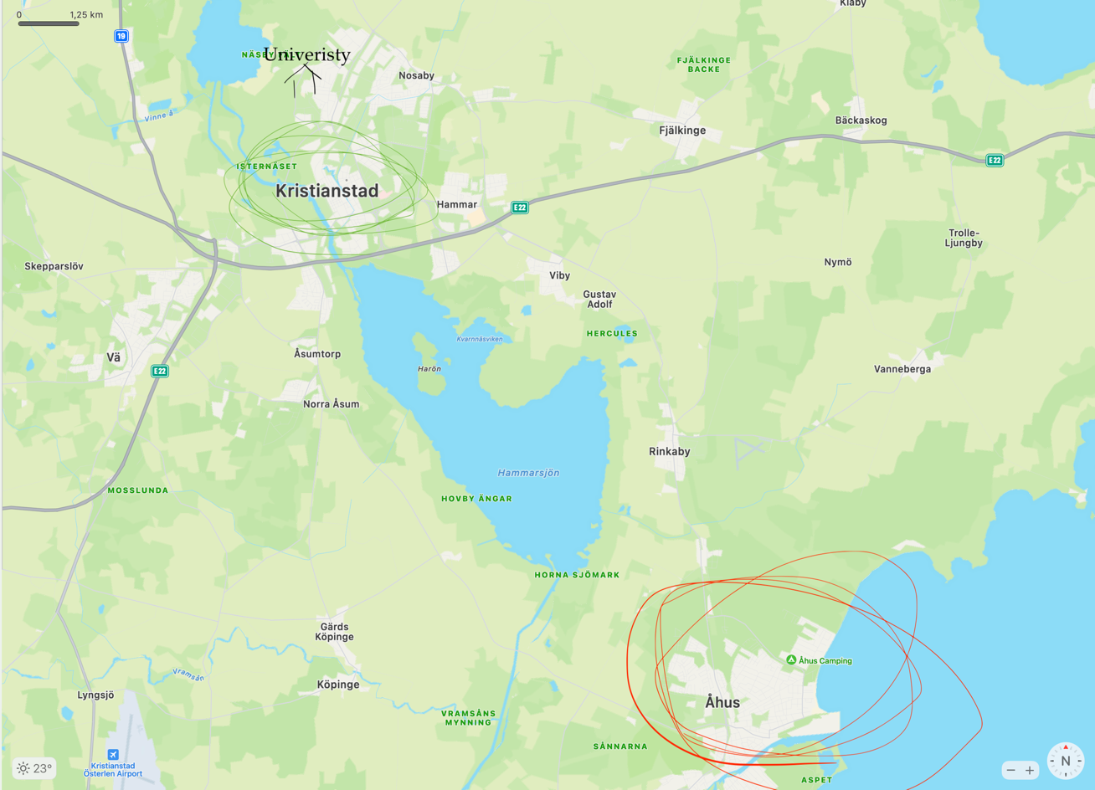
I will recommend on living on the green part, since it is way closer to the school, and usually the community in the people from the residence it’s closer. It is as well closer to the city, so if you want to meet up for an activity, or go for a walk, even just to the supermarket, it is a better idea to live in the school residence close to the city center, called “prison”, since the residence in Åhus is far apart from everything. Even for the school, if you want to go to university, if you live in Åhus, you will have to take a bus every single time, but if you live in the other residence, you could just go walking if you want.

Find a flat or a room
The University of Kristianstad will contact you, therefore there is nothing to do, just wait for them, and they will give you a brochure with the residences, either “prison” or Åhus.

Cost
I paid 1400 euros for the whole semester, which is considerably cheap, and it includes the Wi-Fi, electricity, water bills, laundry machine, etc. The only catch is that they want it all paid up at once, you can’t pay once a month, so you have to save some cash in order to pay all of it at once, but is better, that way you don’t have to worry anymore at all the rest of the semester.

When I arrive at the university

Inscription at the university
Every single part of the inscription is online, communicating with the head of “RI”, which for me was called Karen den Boer, a very nice lady, that helped me all throughout the inscription process, and that you do in their platform, they will contact you via email and tell you about your username and password, and then the inscription is done online in their platform.

Information on the university

Class

-Intercultural Communication: Class was interesting, got to mostly do group projects, doing social gatherings and a big experiment, where you need to put into practice and do a study on how cultures differentiate themselves from others. Certainly will recommend it, it was 15 credits, and it was so fun doing it, it was not as academic, more so about learning about other cultures, more so about life learning.
-International Rhetoric: This class what about speaking, which was so fun. I had the same teacher as the “Intercultural Communication” class, therefore I was feeling confident about it. We learned how to give better presentations and speeches, which to me is very useful, I will recommend it to other students.
-Strategic Management: A very average and repetitive management class, we are watching the same principles since the first year at MOMA, will not recommend it, it is a boring class.

Organization of the Class
-Intercultural Communication: Not a lot of work, the class lasted the whole semester, but the work-ratio was very well divided. The teacher is very fun and such a nice guy.
-International Rhetoric: Same teacher from the class prior. Not a lot of work, just watching videos in how to speak, it lasted just 1 month, and the final work was giving out a speech in front of the class.
-Strategic Management: It lasted 1 month, the teacher here was more demanding, she even wanted us to read a book. The main work was a management report, so no exams, but it took a while to make.

List of courses and recommendation
-Intercultural Communication: Will recommend.
-International Rhetoric: Will recommend.
-Strategic Management: Will not recommend.

Exam
-Intercultural Communication: 1 big group project, and 1 exam about the topics viewed in class.
-International Rhetoric: Just 1 presentation in front of the class.
-Strategic Management: Multiple group homework, and 1 big management report at the end.

When I life there

Safety
Incredibly safe, we are in Sweden, so there is not much insecurity going on. People almost all know each other, since it is a very small town, so there is not much insecurity, I felt safe all throughout my stay.

Phone and Internet
Since it is part of the EU, there is no concern, it works just like in France.

Events
Honestly, since it is a very small town, there are not many events going on, mostly you will hang out with the friends you make at the residences.

Sports
There is a sport club association, where you could practice all the sports, once a week, all throughput the semester.

Eating
There are a couple of food trucks in the university, one of kebab and another one of Vietnamese food, both very good. The university itself has a buffet, but it is not very good, and a bit expensive for the quality of the food, don’t go there.

Go to the university : bus, car, bike
I went walking, it was around a 20 minute walk, usually went with friends of my residence that I shared courses with.

Travels
Main destinations will be Malmö, Copenhagen, and Gothenburg. Out of those ones, my favorite one was Malmö.

Any other information you would have liked to know about

The main thing I would have wanted to know before was the size of the city. Even though the country and the people are great, in general I like more the feel of bigger cities. Some of my other friends went to cities like Madrid and Bologna, and they met so much more people and in general had a more active pace regarding their Erasmus. If you are a big small city person, of course this will not apply to you, but if you are like me, that enjoys big cities, have this in mind when applying to Kristianstad.

After your semester abroad

What are you planning do to?
I want to do a master in finance.

Did you apply for master?
Indeed I applied to a master, through MonMaster, and I am happy to say that I will continue my master studies in Montpellier, at the master of Finance & Green Finance.

