Retour d’expérience   
de ma mobilité internationale

*Louane Guibilato – Guibilato.louane@gmail.com*

[Spain] – [UCLM-Cuenca]

NE PAS REMPLIR DIRECTEMENT (télécharger et renommer)

Agenda[1]

I. Your overall feeling after your semester abroad 2

II. Before the travel 2

A. Preparation 2

1. Visa 2

2. The flight 2

3. My luggage 2

4. Bank account 2

5. Insurance 2

B. Housing 2

1. Where to live 2

2. Find a flat or a room 3

3. Cost 3

III. When I arrive at the university 3

A. Inscription at the university 3

B. Information on the university 3

1. Class 3

2. Organization of the Class 3

3. List of courses and recommendation 3

4. Exam 3

IV. When I life there 3

A. Safety 3

B. Phone and Internet 4

C. Events 4

D. Sports 4

E. Eating 4

F. Go to the university : bus, car, bike 4

G. Travels 4

H. Any other information you would have liked to know about 4

V. After your semester abroad 4

A. What are you planning do to? 4

B. In which master was you accepted 4

# Your overall feeling after your semester abroad

*The experience was okay but not the best. I expected more from this semester abroad. Firstly it’s really important to understand that without speaking Spanish going to this university is really complicated since there is almost no classes in English, not a lot of teachers are able to speak English. To feel included by the student, you also need to speak Spanish because most of them don’t speak English neither. The good point is that after a semester in this university and in the city of Cuenca for me, you go back home with a really good level of Spanish. I also didn’t feel that much included when I arrived in the city because the international events started really late (1 month after). I would not really recommend to go there if you don’t speak a minimum of Spanish. Some classes are interesting and some teacher try to help you following the class.*

|  |
| --- |
| **GRADE : 2**  ***=> 0 (I do not recommend this semester abroad to my best friend) – 5 (I totally recommend this semester to my best friend)*** |

# Before the travel

## Preparation

### Visa

*No*

### The flight

*I came by car, it was 7 hours from the south of France.*

### My luggage

*In winter it’s really cold and dry so warm clothes but in may it starts being really warm also so clothes for the heat. You can take also sport clothes because there is a lot of sport organization and structure in the university. Take your passport if you have one because the flight for Morocco are really cheap from Madrid.*

### Bank account

*No*

### Insurance

*The European insurance*

## Housing

### Where to live

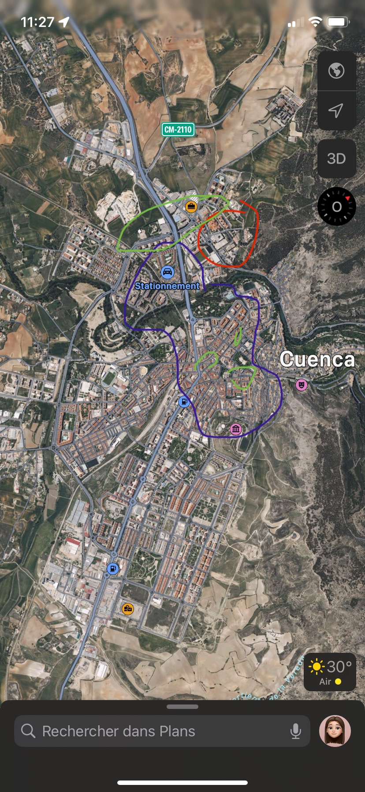*In red it’s the area of uni, and sport fields. On green is all the markets. You have also smalls one in the center. In blue is the area I will recommend you*

### Find a flat or a room

*You have 3 options, you can come to the international office of Cuenca and they will find you an apartment or room for the semester. You can find share apartment or normal one on the website IDEALISTA but it’s better speaking Spanish because it’s private owner and you have to be careful with the fake proposition. The last option is the student residence, which I don’t recommend, you share a flat or a room with someone, one student residence have his own cafeteria where you have to eat everyday at precise hours because there is no kitchen, the other one have kitchen in the flat. You can’t invite friends in the residence. I recommend sharing a flat with other student to improve your English or Spanish.*

### Cost

*You can find apartment for 200€ until 350€ for the most expensive ones. Sometimes you need to pay the electricity separately from the rent.*

# When I arrive at the university

## Inscription at the university

*You need to go to the international office the day you arrive, they will give you all the class that you can chose because sometimes the class you chose on your learning agreement are not dispensed in the semester. You should talk to each teacher to see which class suits you the best and the modality of the exams. Once you have chosen your classes you need to send the LA again to the coordinator and to MOMA. You will only have access to the e-campus once your registration is officially done, so it ‘s better doing it the quickest possible to follow easily the class, because most of the exercise and slide used are on it.*

## Information on the university

### Class

### Organization of the Class

There is not a lot of student it’s class of 60 or 30 people regarding if it’s first grade or third grade. You can ask every question you need to during the class they will explain. You need to attend most of the class. There is 30% of the grade that is about practical (it can be presentation or group work) and 70% for the final exam. The teacher are in there office the rest of the time, you can go to ask question or more explanation on there class. They are mostly open to provide help if you don’t speak Spanish at all.

### List of courses and recommendation

***Fundamentos de administracion de empresas*** *: easy to follow, you can have the final exam in English but the class are in Spanish. You have a practical part with calculus and a theorical part that is mainly about management.*

***Fundamentos de Marketing*** *: if you don’t like theorical class don’t take it because it’s really theorical. The exam is in Spanish and the class also. It’s easy to follow but there is a lot to learn.*

***Dirección de operaciones*** *: I recommend it, it’s really interesting but you need to follow every class or you will be lost. It’s half practical exercise and half theorical. The teacher give a traduction of the slide in English and you can pass the exam in English but the class is in Spanish.*

***Matematicas de las operaciones financieras*** *: the class is in Spanish but the exam can be in English, it’s easy to follow. The teachers are really nice and open to help you.*

***Modelo econometricos*** *: I don’t recommend this class, it’s on a software that the student already used the semester before you will probably feel lost. It’s really hard to follow and it’s also in Spanish.*

### Exam

*The exam had a duration of 2 hours. You have continuous control and final exam. In case you miss the final exam (ordinary exam) you have a second chance (extraordinary exam). Most of the exam was one part practical and one part theorical. The grade is on 10 and you need a 4 at the final exam to pass if you already have a 5 on the continuous grade. Be careful that the second chance is at the end of June and sometimes the beginning of July. In case you pass all the exams you will have your grade in the middle of June.*

# When I life there

## Safety

*It’s really safe, because it’s a small city. I’ve never heard of any one having a problem*

## Phone and Internet

*It’s a European country you can have internet with your french card, but regarding the operator you have, they may block the internet access after 3-4 month. You can still get a card there. I had a subscription at Sosh/Orange and I didn’t have that problem.*

## Events

*There is flyers at uni for the biggest one, they send also on the group chat of the class and finally on the what’s app Erasmus group. The biggest event is Semana Santa (cultural one) and Intercampus (student festival)*

## Sports

*You can do every type of sport there is a lot of infrastructure, but register the first week your arrive because after there is no more availability for most of the sport. If you are enough people you can rent the fields (football, volleyball, handball, tennis, paddle…)*

## Eating

*Between class you can eat at the cafeteria but you need to order before 12. You can order at 12 and pick up the meal at 2 for example. There is a lot of restaurant, but I don’t really recommend it.*

## Go to the university : bus, car, bike

*By walk is the easiest way because the city is not that big, but take a flat near uni. However there is still buses and taxi.*

## Travels

*I recommend Toledo, Madrid, Valencia, Morocco and the ESN Ibiza trip if you go on the second semester and you like partying a lot. There is cheap flight from Madrid to go to Morocco and Portugal. You also should go to the south of Spain (Andalusia).*

## Any other information you would have liked to know about

*There is a « bono » to go to Madrid for the price of 50€, it allows you to go to Madrid as much as you want during 2 months. The bus take 2h/2h30 to go there. If you take the bus 16 times or more you get your money back.*

*Don’t count on ESN on the second semester to get you introduce to other students. You should do it as the moment you arrive by yourself*

# After your semester abroad

## What are you planning do to?

*I’m going to Austria to study a master in tourism in the university of Vienna. (My first Erasmus in St Pölten introduce me to this country that I really liked)*

## Did you apply for master?

*I got accepted for a master in Moma (Gestion de projet Intrapreneurial and Digital) and in Perpignan (tourisme)*

*Ps: I recommend you to prepare yourself for the master you want before the erasmus. Once you are in the Erasmus it ‘s not easy to get yourself in, to apply when you are alone in an other country. Also you will probably need to have the IAE massage test score, or the TOEIC, pass it before your Erasmus it will help you to apply.*

[remember to fill in the excel : <https://lnkd.in/eUt_xB54> ]

1. To update the agenda just click right on your moose