Retour d’expérience   
de ma mobilité internationale

*Martiuk Mariia L3 IM*

*l*

[POLOGNE] – [Jagellonian University]

NE PAS REMPLIR DIRECTEMENT (télécharger et renommer)

Agenda[1]

I. Your overall feeling after your semester abroad 2

II. Before the travel 2

A. Preparation 2

1. Visa 2

2. The flight 2

3. My luggage 2

4. Bank account 2

5. Insurance 2

B. Housing 2

1. Where to live 2

2. Find a flat or a room 3

3. Cost 3

III. When I arrive at the university 3

A. Inscription at the university 3

B. Information on the university 3

1. Class 3

2. Organization of the Class 3

3. List of courses and recommendation 3

4. Exam 3

IV. When I life there 3

A. Safety 3

B. Phone and Internet 4

C. Events 4

D. Sports 4

E. Eating 4

F. Go to the university : bus, car, bike 4

G. Travels 4

H. Any other information you would have liked to know about 4

V. After your semester abroad 4

A. What are you planning do to? 4

B. In which master was you accepted 4

# Your overall feeling after your semester abroad

*[Help : How was your experience abroad? If you could go back I time, would you go to this university and why ?]*

My Erasmus experience was like 100/10, it was the best 4 months in my life abroad. I enjoyed there so much. Krakow basically was my first choice, because I visited this city like 3 times before my Erasmus exchange so I knew it will be the best destination for me. If I could repeat these 4 months I would do it. I was sad to leave my Polish fairytale and go back to French reality, but I am glad that I had an opportunity to be there. Most people say that this country is not interesting, but they just don’t know anything about Poland and especially Krakow.

The university was nice as well, teachers give you an innovative approach of studying, and to be honest, I think that Polish teaching method is even more interesting than French (maybe because it’s Erasmus idk).

I didn’t regret any second that I choose this country and thanks to this Erasmus I am thinking to redo another one exchange semester. This city became my second home.

|  |
| --- |
| **GRADE : [5!!!]**  ***=> 0 (I do not recommend this semester abroad to my best friend) – 5 (I totally recommend this semester to my best friend)*** |

# Before the travel

## Preparation

### Visa

*Personally, I did not need a visa because I have a French titre de séjour which allows me to stay in another country till 3 month and in Poland I was less than 3 months because I had a lot of trips, so normally after each trip my stay in Poland is annulated and I can be there another time for 3 months.*

### The flight

*I took Ryanair flight from Marseille, but you can take another from Toulouse, but personally I preferred from Marseille. The flight cost was like 80-100 euros for me. (By the way, when you arrive at Krakow airport, don’t take a train till the city, you can take a bus, it will be way cheaper (the train cost is 30 zloty and bus it’s 4 zloty (2 if you have already your polish (not a French) student card)*

### My luggage

*As someone who has a lot of clothes and things to bring, I departed with my mother and we took like a big suitcase of 20 kg, 2 small suitcases of 10 kgs and 2 bags in cabin. It was too much and when my mother came to visit me in May, she took like all my winter clothes, so when I was leaving Krakow, I had like a suitcase of 20 kg small suitcase of 10 kg and my Longchamp bag, and it was not enough for me because I also bought a lot of clothes, so basically I paid for extra kg. Small advice: you can to not bring your winter boots, since February I was all the time with my sneakers and it was not that cold, but from the other side, if your parents will visit you like in April – don’t give them all your winter clothes, because the weather in April changes 24/7 and it can be very cold (like there was one week when one day we had 26 degrees outside and two days later it was 3 degrees and snow lol), so you can leave like 2-3 sweaters and it will be enough. (and pls don’t bring a lot of clothes like me, because in Poland all stores are way cheaper so you can buy some clothes there)*

### Bank account

*I had a Revolut account where I can move the money from euro to zloty with no fees (but make attention: if you move 1000 euros per rolling month – it will ask additional fees); Revolut is a really great option because in Poland there is another currency.*

### Insurance

*I took CPAM from Ameli, but !! please do it in advance like 2 months before your Erasmus, because l’Assurance Maladie is very slow, and it took me years to get my CPAM card and I received it like in March (and it is because I contacted them every day and we were speaking like 2 hours on the phone); But if you have a lot of problems with Ameli, like I had, you can contact MOMA RI and they can advice you nice insurance.*

## Housing

### Where to live

*Area in the circle is one which I recommend living because it’s like city center or 20 minutes of walk from the city center. Another area I didn’t visit a lot. And the small blue circle it’s my accommodation, it’s like 20 minutes of walk from the city center. 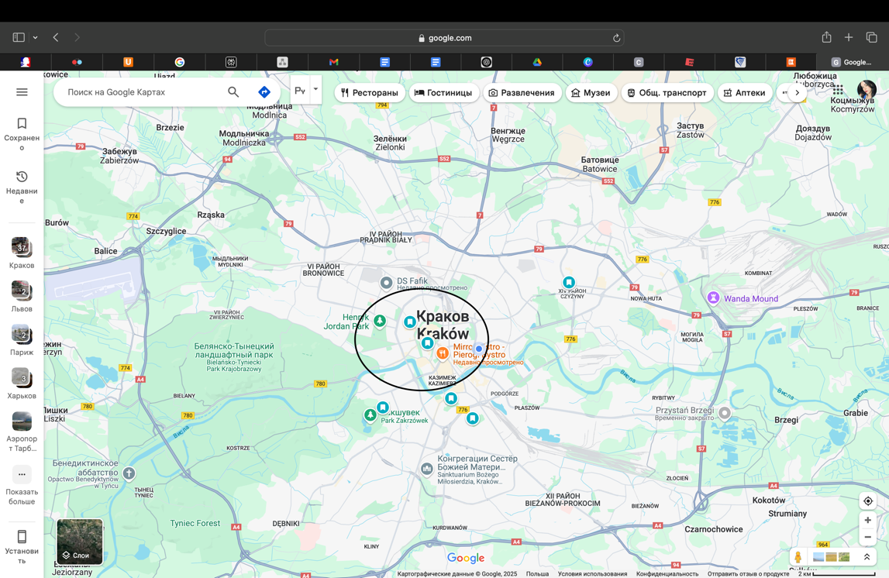*

### Find a flat or a room

*Personally, I prefer to have an apartment at the student accommodation, because there is very nice atmosphere, and you meet a lot of nice people that are living there as well. My choice was Student Depot at Aleja Pokoju 1A, it’s like 20 minutes from the city center. The accommodation is innovative – you have your flat (I had studio with my own bathroom and kitchenette), working area, gym, big kitchen with many ovens and many other options and activities in the dormitory (trust me – you will enjoy there). If you don’t like this accommodation there are so many others near city center, like Milestone, Shed, Next Door. Or you can take the cheapest option – dorms from the uni, but I heard that is a room for 2 with no kitchen and toilette like at the floor for many people.*

*If you are going with someone to Krakow you can search for an apartment to live in collocation, but there is a lot of scams so you need to be attentive.*

### Cost

*I paid like 2750 zlotys per month it’s near 650 euros. But!! You need to precise the date when you are leaving which is impossible because I agreed to have my apartment till 1st July, but I was leaving Krakow like in the second part of June, so they didn’t reimburse me 1 week where I wasn’t here. Small advice: think to bring a lot of stuff from your home, like forks, spoons, towels, even pillows, because there is nothing here and you need to buy it at the place. Also!! Don’t bring your own pots and pans because there is induction boost and it won’t be working there; And btw you don’t need to buy a blanket, it’s really hot at dorms so you basically don’t need it. . What about the prices of other accommodations: Milestone – 700 euros per month; Shed – 680 euros per month; Next Door – 520 euros per month, but it is really long distance from the faculty, you will need to change the tramway 2 times to get there (btw if you think that the faculty is at the city center I hasten to disappoint you – it’s not. I took a tram to get there, and it was like 30 minutes of route)*

# When I arrive at the university

## Inscription at the university

*So, inscription at the university was stressing me out, because Polish administration was slower than I previewed. Till November I didn’t get any news, and I was stressed about this fact, but apparently this is a normal thing. In November, I received my application form which I needed to fulfill, I did it very quickly and they validated my documents after. But it took a lot of time for them and they turned me to this faculty of Law and Administration, so I wrote like a lot of emails about the fact that I am Management student, but after MOMA RI Office contacted the Polish RI Office and they resolved this problem. Registration to the classes you need to do by yourself at the platform Usos (it’s like our ENT) and before that you need to create and validate you Microsoft Teams account, because without that you won’t have any access to Usos. Normally, they will send you some instructions, so there is no problem and before Erasmus don’t forget to check your Outlook email – there are a lot of useful information.*

## Information on the university

### Class

*[Help : for each class tell us how was the class, what did you like and not like, would you recommend it for the next student?]*

*So, I choose 6 classes with 5 ECTS each (because I am lazy and I want to validate quickly my courses) I choose Lean Management, Supply-Chain Management, Semiotics of Advertising, Visual Culture Studies, Basics of Career Orientation and Risk, money decision making. I will tell you about each class briefly:*

*Lean Management – my favorite class from my exchange semester, the teacher was very nice, and we were doing so many interesting workshops during the class, I definitely recommend this class.*

*Supply-Chain Management – not my fav class, but also is interesting, there are so many quizzes and interaction between teacher and students during the class (we had like a Business Game simulation, we had a course with teacher from Canada – it was so interesting). But the teacher is kind of lost during the lesson, but I think that it’s maybe because he could not explain me the material in English, like he is doing it in Polish.*

*Semiotics of Advertising – very nice class with so many visual examples and the lessons with this teacher were funny, but the thing that I did not appreciate it was that we could not use our laptops/iPads/phones during the lesson, because this course needs to be visualized with some pictures, which I could paste from my laptop.*

*Visual Culture Studies – the worst class that I took, if you read this, PLEASE DON’T TAKE THIS CLASS, you will regret so much. Basically, it’s very interesting course and it has a link with Semiotics of Advertising, but the teacher was horrible, like every time she read her early prepared text and did not have an interaction with class (and also, she speaks like very quietly, so if you even make some efforts – you won’t hear her anyway)*

*Basics of Career Orientation – very nice class, the teacher was from Germany, and he was really cute and always interacted with students and tried to make the efforts to know us better. The interesting thing is that there were a lot of students from Psychology faculty, so it was interesting to watch the collaboration between Business Administration students and Psychologists. This class reminded me HRM from the semester in MOMA and I really enjoyed there.*

*Risk, money, decision making – also one is my fav classes from this semester, it was lecture format, but the teacher interacted a lot of with students and his course was interesting to listen, recommend this class.*

*Finally, I recommend you all classes that I took (except Visual Culture Studies), the teaching approach is very innovative there and interesting.*

### Organization of the Class

*[Help : tell us the duration of the class, the volum of work, the behavior of teachers etc. ?]*

*I will tell you schedule and time of which class, so in this way, it will be easier for you to choose your preferences.*

*Lean Management – the class is every Wednesday from 16h45 till 20h and after from 16h45 till 19h. First part of class is like a lecture and second is a workshop according to the notions of the lessons. I know, it’s kinda difficult to concentrate for the second part of the lesson, but you need to do it, because workshops are in groups/pairs every time, and they are really easy so you just need to do some efforts to do it and after the lesson to upload to the Teams (your final grade is based on it). The teacher sees it and verifies your workshop and if the work is done – she will give you a max note.*

*Supply-Chain Management – this class is every Tuesday from 15h till 16h30 and it begins every time from a quiz to test your knowledge about the lesson (don’t worry it’s not graded) Normally, it’s just teacher who speaks every time at the beginning and after the students are doing their tasks in groups which can help to achieve the final task at the end of the course in June. Also, at least one time during the semester, each group needs to present their homework at the class.*

*Semiotics of Advertising – this class is every Thursday from 13H till 15h and it is a lecture format, but the teacher tells her course very interesting.*

*Introduction to the Visual Culture Studies – every Thursday from 11h30 till 13h and I already said that it was a lecture format and it was the worst class.*

*Basics of Career Orientation – this seminar was like only one month, but the problem was that the class was from 8h till 11h each Monday (and one time in Tuesday and Friday), but the teacher was really nice and it was like just for one month so it was deserved to wake up early 6 times in 4 month of my exchange semester.*

*Risk, money decision making – this class is every Friday from 11h30 till 13h. But the class is very interesting to listen and all presentations are on the Teams (btw same for another courses presentations and materials, they are all in the Teams)*

### List of courses and recommendation

*[Help : list your different courses and let us know what do you think : level (easier, same or harder than the 1st semester course at MOMA, what you liked about the content, how is the class organization, who is the professor). Finally, for each class, tell us if you recommend the course.]*

So, the classes are surely easier than in MOMA and teaching approach is very innovative there. Teachers are using different platforms and materials to make the class more interesting, and it is very nice.

### Exam

*[Help : How was the exam? Format? Duration? Grade ]*

*I will tell you about final grade for each course, because there were some courses with final examination and some courses with group projects/workshops/small test etc*

*Lean Management – the final grade for this class was based on 3 conditions: Class attendance – 10 points, Workshops – 50 points and Final test – 40 points. Normally, the workshops are done during the class in the second part, they are easy to do, and you do it in group so it’s cool. It is a course where you can easily get a great note, just doing your workshops in time. My final grade: 5 from 5*

*Supply Chain Management – the final note is composed of group project, the tasks of which you can do during the class and one of this tasks you need to present with your group during the semester. My final grade: 4.5 from 5*

*Semiotics of Advertising – the final note is the assignment where you analyze one of publicity (which you choose by yourself) and the presence during the classes can improve your note as well. My final note: 5 from 5*

*Introduction to the Visual Culture Studies – your final note depends on the final exam. 10 closed questions with the possibility of the multiple-choice (10 points), and 5 open questions requiring a longer answer in the form of analysis or definition    
(15 points). Total score: 25 points. But If a student passes the final test with a grade lower than 65% (good), they may write an essay to improve their grade. My final grade: 4 from 5 ( I didn’t write an essay, I passed my exam from the first time)*

*Basics of Career Orientation – the final note is composed of 2 presentations in groups and the written assignment at the end of the seminar. My final grade: 4.5 from 5*

*Risk, money, decision making – the final note is your test result at the end of the semester. My final grade: 3.5 from 5*

# When I life there

## Safety

*[Help : Is it safe? Is there areas or times I should avoid]*

*I can ensure you that Poland is the safest country in Europe and especially Krakow is very safe. Being a woman, I was not scared to go home alone at 4 AM. Even at 6 AM the city center is a little bit crowded by young people, the tramways start working early and in case of what there are night buses, which is very useful. So, the safety in this city is another one advantage.*

## Phone and Internet

*[Help : How to be able to call and have internet]*

*I have my French number with SFR operator, and I am using it abroad, so I did not buy a polish card, but if you want so, you can do it, but personally, all the time, I used my French number abroad.*

## Events

*[Help : How to know about the events?]*

*There is ESN Krakow group in WhatsApp and there is Instagram account esnujcracow and all events are announced there. At the beginning we had the orientation week with a lot of events, like bowling, pub crawl, city tour etc. Every Monday we had a Tandem party it was very nice, because the drinks are cheap and there is an international music. Every Thursday we went to Klub Studio, which is very nice as well and Saturday we had free access to different clubs in Krakow thanks to Kakao events/Party Animals Krakow (at the beginning they are giving their cards for free, don’t hesitate to take some, because with this cards you can have a free entry and you can pay for drinks less).*

## Sports

*[Help : What sport can I do ? and how?]*

*Personally, I don’t like a group sport, so I enjoy Pilates, yoga and etc. in my dormitory, because they were organizing every week a group seances. Also, in my dormitory there is a gym, so I was doing my sport there and I didn’t pay for smth. But I tried puppy yoga in Krakow and there was Techno yoga in Klub Studio, but the price for participating was very high, so I did not try it (but I wanted so), so if you are yoga lovers you can try it, I can send you a link if you want.*

*From the other side, my friend was doing his volleyball games with ESN Krakow, so you can ask some of ESN coordinators.*

## Eating

*[Help : Any recommendation? Or good tips (e.g. an international house buffet)]*

I have a lot of good recommendations where to eat in Krakow, so if you want I can send you a link of google maps which I created by myself. But in short, you need to try zapiekanki (the best one are in Kazimierz) , pierogi (the best address which I know is Mirror Bistro). The base that you need to try is zabka hotdogs (I swear in Zabka I left at least the SMIC, there are so many good things to try). Also you need to visit a lot of bars in Krakow, they are very good and interesting (the drinks are cheaper than in Montpellier).

## Go to the university : bus, car, bike

*[Help : How did you get access to the bus, car or bike]*

*So, personally, I was getting to the university at the tramway and I was using the tramway like all the time. One time ticket is like 4 zloty (approximately 1 euro), but if you will do the student card of the university, which is totally recommended it will cost 2 zloty (but you need to have your student card every time!!). By the way, Polish controllers are the way more severe than French ones, so buy a ticket every time when you are in the tramway.*

## Travels

*[Help : What do you recommend and what do you not recommend]*

*I have done some travels, but I did not do any travel with ESN Krakow, because I thought they are overpriced. Personally, I have visited Budapest, Vienna, Bratislava and Prague. My advice: don’t hesitate to visit different Polish cities: Gdansk, Wroclaw, Warsaw, Zakopane. I recommend you all the cities that I visited because they are so different, and every city has its own atmosphere.*

## Any other information you would have liked to know about

*[Help : What would I liked to know if I could have gone back in time ]*

*If you are allergic to pollen like me so I advise you so much to bring a lot of medicaments and to have a consultation with the doctor there (even if it is generalist, in Poland it’s pediatr (in polish) by the way). I had virus which was provoked by my allergies so all March I was so sick, and I didn’t know what was with my immune system before I went to the doctor and she explained the problem. So, make attention there, because in Montpellier I didn’t have a strong allergy, but in Poland it was so horrible. And btw prepare yourself to the weather which changes every time there, in one day we could have rain/sun/snow and it was normal thing there. Also, don’t hesitate to participate in all Polish cultural events, they are really cool there and it allows you to explore the culture of this nice country!!*

# After your semester abroad

## What are you planning do to?

*[Help : What do you want to do next year ]*

*I am planning to do my master degree at the same university, where I got my bachelor degree*

## Did you apply for master?

*[Help : in which master where you accepted]*

*I was accepted in Montpellier Management for Management and Business Development, so if you have a question about this Master degree don’t hesitate to contact me (and if you are doing the same Erasmus contact me as well, I will appreciate it and obviously I could help you with any issues during your stay in Krakow)*

*There are my coordinates, my Instagram: mmartyuk*

*Or my e-mail: mmartuk10@gmail.com*

[remember to fill in the excel : <https://lnkd.in/eUt_xB54> ]

1. To update the agenda just click right on your moose