Exercise: read the articles and answer the question:   
"The privatization of the Française des jeux:   
a strategic decision?"

|  |
| --- |
| Article 1: Dicharry E. (2019), "Privativation of the FDJ: a winning bet for the State", *Les Echos, "https://www.lesechos.fr/industrie-services/services-conseils/fdj-la-privatisation-est-lancee-1146346"* |

**"Privativation of the FDJ: a winning bet for the State**

### *The state has decided to sell 52% of the 72% it holds in the gambling operator. It raked in more than 2 billion. […] The FDJ will be officially listed on November 21, 2019.*

### FDJ ready to go public

The process of privatizing Française des Jeux and listing it on the stock market was officially launched on November 7, 2019. Subscription has been open to individuals and institutional investors.

The State has decided to sell 52% of the capital of the public gambling operator, to keep only 20%. At the end of the operation, individuals will hold more than 21% and the group's employees between 5% and 7%, said the Minister of the Economy, Bruno Le Maire, at the end of the subscription on November 20. The veterans' associations, which were behind the creation of the National Lottery in 1933, held 13.4%, will see their position slightly strengthened.

### Jackpot for the State

The State raked in around €2 billion by selling 52% of the FDJ's capital. Some 501,000 individuals (individuals and FDJ retailers) took part in the operation, the share price having been set at 19.50 euros for them. It amounts to 19.90 euros for institutional investors - at the top of the price range offered. "The operation has exceeded all our expectations," said the Minister of the Economy.

The first listing is scheduled for November 21. FDJ's market capitalization stands at €3.8 billion. This is the largest IPO since Amundi's in 2015.

|  |
| --- |
| Article 2: Sandra Mathorel, François Monnier and Philippe Wenger (2019), "The State must invest in strategic companies", *Les Echos*, <<https://investir.lesechos.fr/actionnaires/interview/l-etat-doit-investir-dans-les-entreprises-strategiques-1881634.php>> |

The life of the shareholders

investir.fr | The 15/11/19 at 17:35

**Interview with Bruno Le Maire, Minister of the Economy and Finance**

*The Française des Jeux will remain part of the national heritage. No foreign investor will be able to take control of it.*

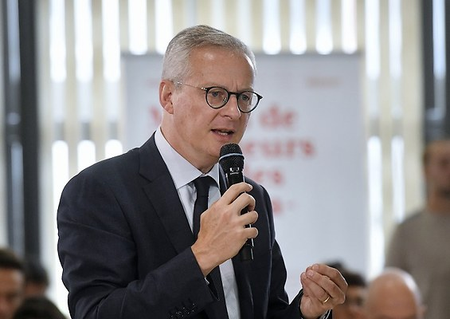  
Bruno Le Maire, Minister of the Economy and Finance

**The opening of the capital of the Française des Jeux was launched last week. How do you justify this decision to sell the national heritage?**

This operation contributes to the redefinition of the State's shareholder strategy. What is the role of the State today? Should it behave like a management company and manage dividends from commercial companies? I don't think so. The State must invest in strategic companies, prepare the future of the French people and protect sectors that could be affected by aggressive investments. The FDJ is not a strategic company, so the State can sell its majority stake in its capital. But a minority stake in the capital does not mean fewer guarantees for the regulatory state. Protections against gambling addiction or money laundering will be stronger after than before privatization.

We have created a National Gaming Authority that will have all the powers to ban games that are likely to be addictive. It will control the return to players rate so that it does not exceed 75% on lottery games. The state will have three positions on the board of directors, and a government commissioner will also be present. Finally, the State will approve any investor wishing to take a stake of more than 10% of the capital. The FDJ is part of the national heritage – as you rightly pointed out – it will continue to be part of the heritage of the French people, no foreign investor will be able to take control of it.

**What arguments can be brought to French savers to encourage them to participate in the operation which lasts until the 20th of this month?**

From November 19 at 8 p.m., individuals will no longer be able to subscribe to FDJ shares. So there are only a few days left. I am not a financial advisor and I invite the French to take into consideration the advice of their bank, but what I observe is that FDJ is a solid company, in a market with very good sales figures and growth forecasts. Institutional investors have shown significant interest in the company and many individuals have already applied to subscribe for FDJ shares.

**On what criteria will you judge this privatization to be a popular success? Number of individual shareholders? Stock price rise?**

The more French people who have subscribed to FDJ shares, the more successful this privatization will be. It's as simple as that.

**The new PER, designed to dust off retirement savings, has just been officially launched. According to a recent survey by Deloitte, two out of three French people have "never heard of" this new product. Don't you think that this reform has missed its target?**

It has just been launched, on October 1st. And I know that insurers and banks are in the process of informing their customers about this: they send letters, emails, they advise directly. Believe me, the French are starting to hear about it. I recently brought together all the financial professionals to take stock of the launch of the product, and their conclusion is unanimous: the reception of savers is very favourable and the beginnings are more than promising. The new retirement savings plan completely renews the various retirement savings products.

Between the Perp, the Perco, the Madelin, Article 83, there was enough to get lost. The products were difficult to understand, not very advantageous and above all not very flexible. A saver could not transfer his savings from one product to another during a professional retraining. The PER is simpler, the same rules will be shared by all. It is more advantageous, because the sums voluntarily paid by the saver into his PER are deductible from the income tax base. It is more flexible, because savings will be portable from one product to another in the event of a career change and because there will be total freedom to withdraw as a lump sum or as an annuity for the sums saved individually. The French will very quickly appropriate this new product.