Group 1– Novo Nordisk -Cities Changing Diabetes Moonshot
Assignment:
- Answer the following questions :
  - Slide 1: Present quickly Novo Nordisk and the program “Cities Changing Diabetes”
  - Slide 2: Is “Cities Changing Diabetes” a moonshot?
  - Slide 3: Why is Novo Nordisk targeting this moonshot? Why is it counter-intuitive?
  - Slide 4: What are the Open Innovation practices?

Remark : use the articles to construct the answer but you can also develop answer we ideas that are not in the articles

- The group has to present their answers in 15 minutes max

Novo Nordisk (2020), “The Novo Nordisk Way” < https://www.novonordisk-us.com/whoweare/about-novo-nordisk/novo-nordisk-way.html>

The Novo Nordisk Way is a set of guiding principles which underpins every decision we make.
It describes who we are, how we work and what we want to achieve, and sets a clear direction for our company and our employees.
Ultimately, it’s a promise we make to each other - and to the millions of patients all over the world who rely on our products to lead full and healthy lives.

Novo Nordisk Way is our way
In 1923, our Danish founders began a journey to change diabetes. Today, we are thousands of employees across the world with the passion, skills and commitment to drive change to defeat diabetes and other serious chronic diseases.
We aim to lead in all disease areas in which we are active.
Our key contribution is to discover and develop innovative biological medicines and make them accessible to patients throughout the world.
Growing our business and delivering competitive financial results is what allows us to help patients live better lives, offer an attractive return to our shareholders and contribute to our communities.
Our business philosophy is one of balancing financial, social and environmental considerations - we call it 'The Triple Bottom Line'.
The Novo Nordisk Way is a set of guiding principles which underpins every decision.

Novo Nordisk (2019), “Cities Changing Diabetes: a global fight against urban diabetes” < https://www.healtheuropa.eu/cities-changing-diabetes/89891/>

Cities Changing Diabetes brings together businesses, researchers, policymakers and urban planners to tackle the worrying rise of diabetes and obesity in cities – the new battleground for public health.
You might think that for Novo Nordisk, the world’s biggest producer of insulin, the alarming rise of diabetes across the globe is good news. This could not be further from the truth because the rapid growth of this disease is completely unmanageable for society.
Today, more than 400 million adults around the world have diabetes,¹ but if action is not taken, this is set to rise to 736 million by 2045. The disease is shortening the lives of millions of citizens and constraining economic growth – and it risks stifling health systems as well as the global economy.
Medicine plays a critical role in the treatment of diabetes and in slowing its progression, but if we are to stop this epidemic from crippling our world, we must look beyond medicine to tackle the disease. Adequate treatment and prevention must work hand in hand.

Can we bend the curve on diabetes?
Cities Changing Diabetes, initiated by Novo Nordisk in partnership with University College London, UK, and Steno Diabetes Center, Denmark, in 2014, is a global fight against urban diabetes. It is now a growing global partnership consisting of 19 cities – home to over 130 million people – and well over 100 expert partners who are united in the fight against diabetes.
Our ambition is to bend the curve on diabetes – which means holding the rise of diabetes at a ceiling of one in ten adults living with the condition. To do this, ambitious action is needed on the single biggest modifiable risk factor for diabetes: obesity.
To bend the curve on diabetes, obesity must be reduced by 25% globally between now and 2045. Achieving this would halt the continuing rise of diabetes and prevent more than 100 million people from developing the disease.
If action is not taken, there will be a very different picture, with the prevalence of diabetes set to continue to rise from 9.1% in 2017 to 11.7% in 2045. This demonstrates how urgent the action required is.
These projections were done using the Diabetes Projection Model which plots the trajectory of diabetes over time. Part of the Urban Diabetes Toolbox,² the tool helps countries and cities to forecast the impact that reducing obesity could have on both the prevalence and cost of diabetes. The model gives two scenarios:
- Illustrating how the diabetes prevalence will continue to increase if the obesity rate continues to rise along the current trend
- Illustrating how the diabetes prevalence will bend if the obesity rate is decreased by 25% by 2045 compared to 2017.
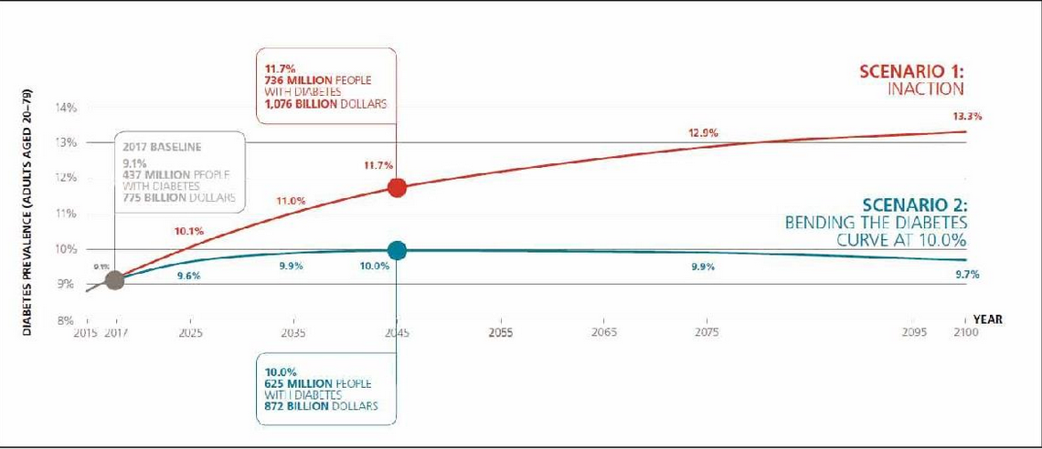

Cities are the front line of the diabetes challenge
But why are Novo Nordisk and the Cities Changing Diabetes programme so concerned with tackling diabetes at the city level? Despite half of the world’s population now living in urban areas, their populations make up two thirds of the world’s cases of diabetes. The way cities are designed, built, and run creates health benefits and job opportunities for citizens. But cities also concentrate risks and hazards that can promote the development of diabetes. More sedentary lifestyles, insufficient physical activity and a higher intake of unhealthy foods all play a part.
To tackle the challenge, cities must understand how their communities live and work in order to develop the best interventions and start to engender a shift in attitude and culture in how we look at our own health and the health of those around us.
The programme welcomes a wide range of partners – researchers, businesses, city governments, non-governmental organisations, faith-based groups, employers and health providers. Their knowledge and commitment are key to driving change. Cities Changing Diabetes depends on new partnerships that are forging new ways of working, trialling interventions and new ideas, sharing what does and does not work.

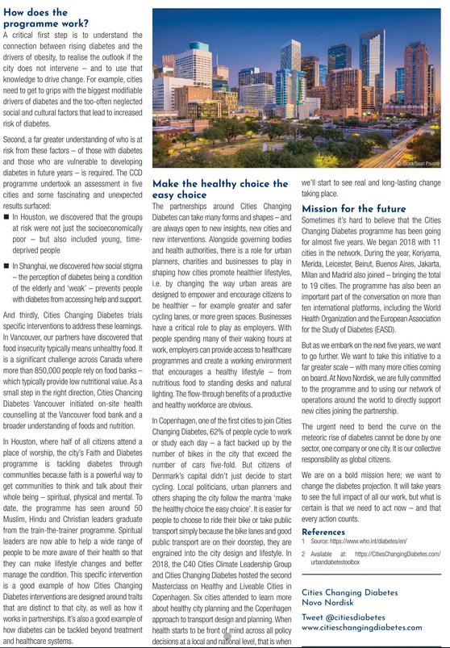

Novo Nordisk (2020), novonordisk.com “Sustainable Development Goals”<https://www.novonordisk.com/sustainable-business/Reporting-and-transparency/sustainable-development-goals-.html>

The 17 Sustainable Development Goals (SDGs) are a framework to end poverty, protect the planet and ensure prosperity for all. For the goals to be reached, everyone needs to do their part: governments, civil society and the private sector.

Our approach to the SDGs
We see the Sustainable Development Goals as an opportunity to step up on sustainability, providing better health care for more people and delivering on an aspiration of zero environmental impact by 2030.
We work through partnerships with both public and private organisations across multiple goals. We particularly welcome the recognition of the importance of the growing burden of diabetes and other non-communicable diseases (NCDs).
Our approach to the SDGs is based on the three bearing principles of the SDGs:
1. Universality - the SDGs apply to every nation and every sector. Cities, businesses, schools, organisations, all are challenged to act.
2. Integration - the SDGs are all inter-connected in a system. The world has not succeeded until all of the SDGs have been achieved.
3. Transformation - achieving the SDGs involves making very big, fundamental changes in how we live on Earth.
Understanding where we make the most impact
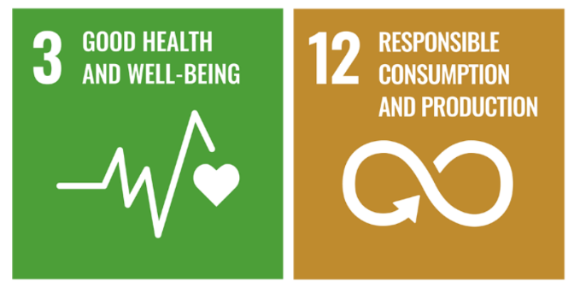
We believe, that we first need to understand where we can maximise our positive impact and minimise our negative impact on the SDGs. We have therefore conducted a materiality assessment of all 169 targets towards the materiality of our operations and license to operate. We have used the SDG Self-Assessment Tool developed by the Earth Security Group together with SAB Miller plc.
The conclusion of the assessment is that we will have the most impact on Goal 3 on Health and Goal 12 on Responsible Consumption and Production.
You can read more on what we currently do to maximise our positive impact and minimise our negative impact on Goal 3 and Goal 12.
Partnering to do more
We work in partnerships on the interrelatedness of the SDGs. We find this has the best potential for transformative solutions. A good example is our Cities Changing Diabetes partnership programme, where we also touch upon Goals 11, 13 and 17.
Cities Changing Diabetes works with more than 100 local partners to map and analyse root causes of urban diabetes and provide solutions to address systemic issues related to healthy living in cities. For example by collaborating with C40, the programme promotes actions in cities that provide both climate and health benefits.

Making a greater impact going forward
We have been investigating how we can apply the SDGs to achieve greater impact going forward. We are working together with the Future Fit Foundation to calculate how we contribute to the SDGs by both looking at Future-Fit Break-Even Goal and potential positive pursuits. In 2018, we finalised the first ever calculation of the 23 Break-Even Goals and had the work assured. As our initial calculations showed, we do really well on some of the Break-Even Goals and have work to be done on others.
On a scale from 0 till 100, our scores on the Break-Even Goals fall as follows:
10 have a score from ≥75 till 100
6 have a score from ≥25 till ≤75
7 have a score from 0 till ≤25
We expect to be sharing the details of the scores in 2019.

