Markkula Center (2021), “A Framework for Ethical Decision Making”, scu.edu <https://www.scu.edu/ethics/ethics-resources/ethical-decision-making/a-framework-for-ethical-decision-making/>

A Framework for Ethical Decision Making

This document is designed as an introduction to thinking ethically. Read more about what the framework can (and cannot) do.
We all have an image of our better selves—of how we are when we act ethically or are “at our best.” We probably also have an image of what an ethical community, an ethical business, an ethical government, or an ethical society should be. Ethics has to do with all these levels—acting ethically as individuals, creating ethical organizations and governments, and making our society as a whole more ethical in the way it treats everyone.

What is Ethics?
Ethics refers to standards and practices that tell us how human beings ought to act in the many situations in which they find themselves—as friends, parents, children, citizens, businesspeople, professionals, and so on. Ethics is also concerned with our character. It requires knowledge, skills, and habits.
It is helpful to identify what ethics is NOT:
- Ethics is not the same as feelings. Feelings do provide important information for our ethical choices. However, while some people have highly developed habits that make them feel bad when they do something wrong, others feel good even though they are doing something wrong. And often our feelings will tell us that it is uncomfortable to do the right thing if it is difficult.
- Ethics is not the same as religion. Many people are not religious but act ethically, and some religious people act unethically. Religious traditions can, however, develop and advocate for high ethical standards, such as the Golden Rule.
- Ethics is not the same thing as following the law. A good system of law does incorporate many ethical standards, but law can deviate from what is ethical. Law can become ethically corrupt—a function of power alone and designed to serve the interests of narrow groups. Law may also have a difficult time designing or enforcing standards in some important areas and may be slow to address new problems.
- Ethics is not the same as following culturally accepted norms. Cultures can include both ethical and unethical customs, expectations, and behaviors. While assessing norms, it is important to be culturally sensitive to others and to recognize how one’s ethical views can be limited by one’s own cultural perspective or background.
- Ethics is not science. The social and natural sciences can provide important data to help us make better and more informed ethical choices. But science alone does not tell us what we ought to do. Some things may be scientifically or technologically possible and yet unethical to develop and deploy.

Six Ethical Lenses
If our ethical decision-making is not solely based on feelings, religion, law, accepted social practice, or science, then on what basis can we decide between right and wrong, good and bad? Many philosophers, ethicists, and theologians have helped us answer this critical question. They have suggested a variety of different lenses that help us perceive different ethical dimensions. Here are six of them:

The Rights Lens
Some suggest that the ethical action is the one that best protects and respects the moral rights of those affected. This lens starts from the belief that humans have a dignity based on their human nature per se or on their ability to choose freely what to do with their lives. On the basis of such dignity, humans have a right to be treated as ends in themselves and not merely as means to other ends. The list of moral rights—including the rights to make one’s own choices about what kind of life to lead, to be told the truth, to not be injured, to a degree of privacy, and so on—is widely debated; some argue that non-humans have rights, too. Rights are also often understood as implying duties—in particular, the duty to respect the rights and dignity of others.
(For further elaboration on the rights lens, please see our essay, “Rights.”)

The Justice Lens
Justice is the idea that each person should be given their due, and what people are due is often interpreted as fair or equal treatment. Equal treatment implies that people should be treated as equals according to some defensible standard such as merit or need, but not necessarily that everyone should be treated in the exact same way in every respect. There are different types of justice that address what people are due in various contexts. These include social justice (structuring the basic institutions of society), distributive justice (distributing benefits and burdens), corrective justice (repairing past injustices), retributive justice (determining how to appropriately punish wrongdoers), and restorative or transformational justice (restoring relationships or transforming social structures as an alternative to criminal punishment).
(For further elaboration on the justice lens, please see our essay, “Justice and Fairness.”)

The Utilitarian Lens
Some ethicists begin by asking, “How will this action impact everyone affected?”—emphasizing the consequences of our actions. Utilitarianism, a results-based approach, says that the ethical action is the one that produces the greatest balance of good over harm for as many stakeholders as possible. It requires an accurate determination of the likelihood of a particular result and its impact. For example, the ethical corporate action, then, is the one that produces the greatest good and does the least harm for all who are affected—customers, employees, shareholders, the community, and the environment. Cost/benefit analysis is another consequentialist approach.
(For further elaboration on the utilitarian lens, please see our essay, “Calculating Consequences.”)

The Common Good Lens
According to the common good lens, life in community is a good in itself and our actions should contribute to that life. This approach suggests that the interlocking relationships of society are the basis of ethical reasoning and that respect and compassion for all others—especially the vulnerable—are requirements of such reasoning. This approach also calls attention to the common conditions that are important to the welfare of everyone—such as clean air and water, a system of laws, effective police and fire departments, health care, a public educational system, or even public recreational areas. Unlike the utilitarian lens, which sums up and aggregates goods for every individual, the common good lens highlights mutual concern for the shared interests of all members of a community.
(For further elaboration on the common good lens, please see our essay, “The Common Good.”)

The Virtue Lens
A very ancient approach to ethics argues that ethical actions ought to be consistent with certain ideal virtues that provide for the full development of our humanity. These virtues are dispositions and habits that enable us to act according to the highest potential of our character and on behalf of values like truth and beauty. Honesty, courage, compassion, generosity, tolerance, love, fidelity, integrity, fairness, self-control, and prudence are all examples of virtues. Virtue ethics asks of any action, “What kind of person will I become if I do this?” or “Is this action consistent with my acting at my best?”
(For further elaboration on the virtue lens, please see our essay, “Ethics and Virtue.”)

The Care Ethics Lens
Care ethics is rooted in relationships and in the need to listen and respond to individuals in their specific circumstances, rather than merely following rules or calculating utility. It privileges the flourishing of embodied individuals in their relationships and values interdependence, not just independence. It relies on empathy to gain a deep appreciation of the interest, feelings, and viewpoints of each stakeholder, employing care, kindness, compassion, generosity, and a concern for others to resolve ethical conflicts. Care ethics holds that options for resolution must account for the relationships, concerns, and feelings of all stakeholders. Focusing on connecting intimate interpersonal duties to societal duties, an ethics of care might counsel, for example, a more holistic approach to public health policy that considers food security, transportation access, fair wages, housing support, and environmental protection alongside physical health.
(Our essay elaborating further on the care ethics lens is forthcoming.)

Using the Lenses
Each of the lenses introduced above helps us determine what standards of behavior and character traits can be considered right and good. There are still problems to be solved, however.
The first problem is that we may not agree on the content of some of these specific lenses. For example, we may not all agree on the same set of human and civil rights. We may not agree on what constitutes the common good. We may not even agree on what is a good and what is a harm.
The second problem is that the different lenses may lead to different answers to the question “What is ethical?” Nonetheless, each one gives us important insights in the process of deciding what is ethical in a particular circumstance.

Making Decisions
Making good ethical decisions requires a trained sensitivity to ethical issues and a practiced method for exploring the ethical aspects of a decision and weighing the considerations that should impact our choice of a course of action. Having a method for ethical decision-making is essential. When practiced regularly, the method becomes so familiar that we work through it automatically without consulting the specific steps.
The more novel and difficult the ethical choice we face, the more we need to rely on discussion and dialogue with others about the dilemma. Only by careful exploration of the problem, aided by the insights and different perspectives of others, can we make good ethical choices in such situations.
The following framework for ethical decision-making is intended to serve as a practical tool for exploring ethical dilemmas and identifying ethical courses of action.

A Framework for Ethical Decision Making
Identify the Ethical Issues
- Could this decision or situation be damaging to someone or to some group, or unevenly beneficial to people? Does this decision involve a choice between a good and bad alternative, or perhaps between two “goods” or between two “bads”?
- Is this issue about more than solely what is legal or what is most efficient? If so, how?
Get the Facts
- What are the relevant facts of the case? What facts are not known? Can I learn more about the situation? Do I know enough to make a decision?
- What individuals and groups have an important stake in the outcome? Are some concerns more important? Why?
- What are the options for acting? Have all the relevant persons and groups been consulted? Have I identified creative options?
Evaluate Alternative Actions
- Evaluate the options by asking the following questions:
- Which option best respects the rights of all who have a stake? (The Rights Lens)
- Which option treats people fairly, giving them each what they are due? (The Justice Lens)
- Which option will produce the most good and do the least harm for as many stakeholders as possible? (The Utilitarian Lens)
- Which option best serves the community as a whole, not just some members? (The Common Good Lens)
- Which option leads me to act as the sort of person I want to be? (The Virtue Lens)
Choose an Option for Action and Test It
- After an evaluation using all of these lenses, which option best addresses the situation?
- If I told someone I respect (or a public audience) which option I have chosen, what would they say?
- How can my decision be implemented with the greatest care and attention to the concerns of all stakeholders?
Implement Your Decision and Reflect on the Outcome
- How did my decision turn out, and what have I learned from this specific situation? What (if any) follow-up actions should I take?
This framework for thinking ethically is the product of dialogue and debate at the Markkula Center for Applied Ethics at Santa Clara University. Primary contributors include Manuel Velasquez, Dennis Moberg, Michael J. Meyer, Thomas Shanks, Margaret R. McLean, David DeCosse, Claire André, Kirk O. Hanson, Irina Raicu, and Jonathan Kwan. It was last revised on November 5, 2021.
Sum up
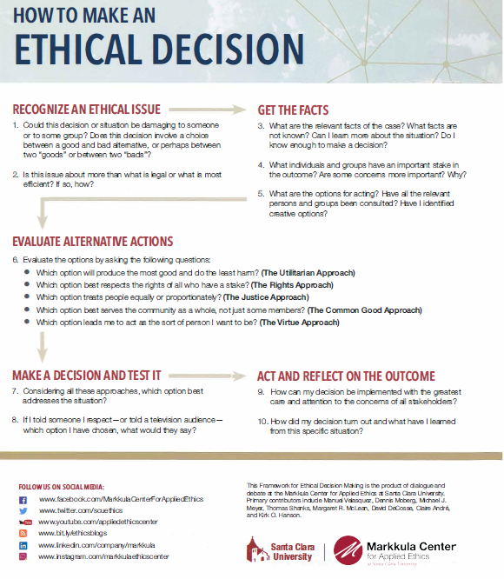

Additional Resources on the Ethical Lenses:
The Rights Lens
- How to Use the Rights Test
- How to Use the Choices Test
The Justice Lens
- How to Use the Justice or Fairness Test
The Utilitarian Lens
- How to Use the Utility Principle
The Common Good Lens
- How to Use the Common Good Test
The Virtue Lens
- How to Use the Virtue and Character Test

