Group 6 – China’s space solar power
Assignment:
- Answer the following questions :
  - Slide 1: Present China’s space solar power
  - Slide 2: Is “China’s space solar power” a moonshot?
  - Slide 3: Why is China’s targeting a space solar power?
  - Slide 4: What are the Open Innovation practices?

Remark : use the articles to construct the answer but you can also develop answer we ideas that are not in the articles

The group has to present their answers in 15 minutes

https://sdgcompass.org/sdgs/sdg-7/

SDG 7: Ensure access to affordable, reliable, sustainable and modern energy for all

The role of business
Modern society depends on reliable and affordable energy services to function smoothly and to develop equitably. A well-established energy system supports all sectors from medicine and education to agriculture, infrastructure, communications and high-technology. Intensive development patterns have historically relied on inexpensive and energy-dense fossil fuels, which also happen to be the primary source of greenhouse gas emissions contributing to climate change. However, new, clean technologies are available that can reorient development along a more sustainable trajectory.
Business can accelerate the transition to an affordable, reliable and sustainable energy system by investing in renewable energy resources, prioritizing energy efficient practices, and adopting clean energy technologies and infrastructure. Also, with investment in R&D, businesses can innovate and pioneer new technologies that change the status quo of the global energy system, becoming the center of climate change solutions.

Key business themes addressed by this SDG
- Electricity access
- Electricity availability and reliability
- Renewable energy
- Energy efficiency
- Infrastructure investments
- Environmental investments
The below examples are non-exhaustive and some may be more relevant to certain industries than to others.
- Ensure that all employees and their families have access to a reliable and affordable source of energy by investing in local infrastructure to establish accessible energy services.
- Commit to sourcing 100% of operational electricity needs from renewable sources.
- Reduce the internal demand for transport by prioritizing telecommunications and incentivize less energy intensive modes such as train travel over auto and air travel.
- Invest in R&D related to sustainable energy services, bringing new technologies to the market quickly.
- Integrate renewable energy into employee benefits packages, subsidizing the capital expenditures associated with residential solar or electric vehicle investments.
- As women typically drive much of the energy consumption at the household level, companies have an opportunity to invest and train women to become renewable energy entrepreneurs.
- Prioritize energy efficiency across operations through tools such as the use of an internal carbon price and science-based target setting to reduce overall demand for energy.

The SDG targets
7.1 By 2030, ensure universal access to affordable, reliable, and modern energy services
7.2 Increase substantially the share of renewable energy in the global energy mix by 2030
7.3 double the global rate of improvement in energy efficiency by 2030
7.a By 2030, enhance international cooperation to facilitate access to clean energy research and technologies, including renewable energy, energy efficiency, and advanced and cleaner fossil fuel technologies, and promote investment in energy infrastructure and clean energy technologies
7.b By 2030, expand infrastructure and upgrade technology for supplying modern and sustainable energy services for all in developing countries, particularly LDCs and SIDS

Rosenbaum and Russi (2019), “China plans a solar power play in space that NASA abandoned decades ago”, <https://www.cnbc.com/2019/03/15/china-plans-a-solar-power-play-in-space-that-nasa-abandoned-long-ago.html>

China plans a solar power play in space that NASA abandoned decades ago
Key Points
- Science-fiction writer Isaac Asimov is credited with bringing the idea of space-based solar power projects to prominence in 1941.
- Space stations and satellites already use solar panel arrays for their power needs, but NASA abandoned the concept of stand-alone space solar after some study decades ago.
- The idea of building renewable-energy projects in space to beam the sun’s energy back to Earth is controversial but could fundamentally reshape the way every person and business on the planet receive electricity.
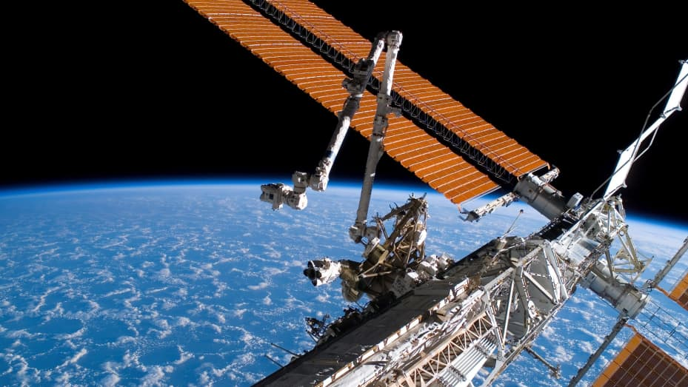
John Mankins has spent his professional life working on novel ideas that could transform the way humans use technology in space, solar power among them. But Mankins’ interplanetary musings went beyond the way solar is already used to power satellites and the International Space Station. During a 25-year career at NASA and CalTech’s Jet Propulsion Laboratory, he devised multiple concepts to extend the use of solar in space, among them a solar-powered interplanetary transport vehicle and a space-based power system.
A solar panel array attached to the International Space Station.NASA | Getty Images News | Getty Images

It’s that second idea, in particular, that had Mankins’ attention while holding top research positions at NASA during the 1990s and 2000s, including overseeing the $800 million Exploration Systems Research and Technology group. Mankins — who now runs his own private aerospace firm, Artemis Innovation Management Solutions — had the task of figuring out whether there was a way to deliver electricity to the planet by beaming it from space. It’s an idea that could fundamentally reshape the idea of the utility business — and give control over it, on a global scale, to whichever world power gets there first.
“If you can dramatically lower the cost of space solar, you can take over most of the energy market of the world,” said Mark Hopkins, a member of the National Space Society board of directors and former Rand Corp. executive.
Mankins got close to seeing the idea make it into reality, with support from the Bush White House and Congress in the 2000s, and positive reviews from the National Academy of Sciences and a national security unit within the Department of Defense. But the program never took flight, for a variety of reasons. So when the news recently broke that the idea — abandoned decades ago by NASA — was coming back to life with a big push from government, it was cause for excitement. But it isn’t NASA finally backing the idea. It’s the Chinese government.

The space race heats up
China’s ambitions in space rival that of the United States. Its two main objectives were originally human spaceflight (accomplished in 2003) and a permanent Chinese space station, which is coming closer to reality — it announced in early March that a manned space station similar to ISS is now on schedule for 2022, earlier than expected.
As the two geopolitical foes increasingly turn their attention to a technological and military race beyond the earth’s atmosphere, space-based solar power projects are an overlooked, often criticized idea. But with China recently announcing that within the next decade it expects to finish the high voltage power transmission and wireless energy tests that would be needed for a space-based solar power system, the concept is likely to get renewed attention.
All of the plans in the space race have potential implications for a new military build-out in space of increasing relevance to the world’s powers. The Trump administration formalized plans in February for a branch of U.S. military known as the Space Force. The solar power station plans being contemplated by China include the launch of small- to medium-sized solar power projects in the stratosphere to generate electricity between 2021 and 2025, followed by a space-based solar power station that can generate at least a megawatt of electricity in 2030, and a commercial-scale solar power plant in space by 2050.
This is not posturing; this is a real plan from serious organizations with revered scientists in China. They have a perfectly good technical plan, and they can do it by 2030.
John Mankins
president of space systems and technology firm Artemis Innovation Management Solutions
“The dramatically stated interest on the part of the Chinese will do a lot to engender interest,” Mankins said. “Around a decade ago the Chinese started working seriously on this, and about five years ago they started coming to international meetings. Before that, they were in the dark. Now they are coming out of the shadows and talking much more openly about this.” He added, “There is absolutely progress from the Chinese at this point. This is not posturing; this is a real plan from serious organizations with revered scientists in China. They have a perfectly good technical plan, and they can do it by 2030,” Mankins said, describing a small-scale solar power project producing megawatts of electricity, but not a commercial-scale project able to produce gigawatts needed to compete with utilities.
A space-based solar power station would capture the sun’s energy that never makes it to the planet and use laser beams to send the energy back to Earth to meet energy demand needs. China said in a recent announcement about the project that a big advantage of space-based solar power is its ability to offer energy supply on a constant basis and with greater intensity than terrestrial solar farms.
One of the issues with renewable-energy projects like solar and wind power plants are their intermittency — that refers to the fact that the sun isn’t shining and the wind is not blowing 24-hours a day, limiting the periods of time during which these projects can be a source of power generation.
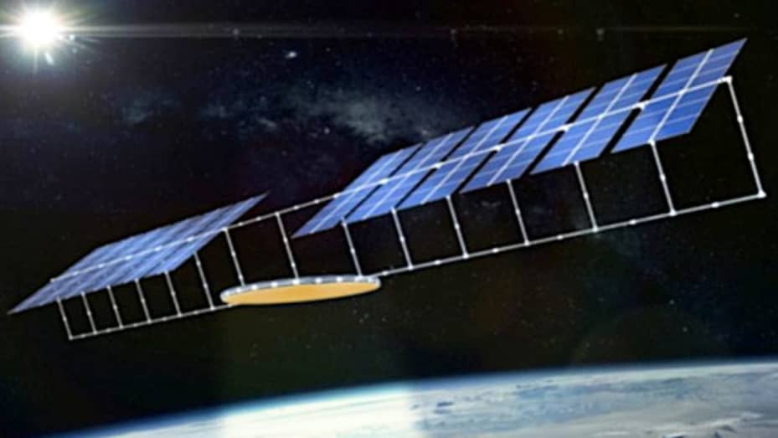
A slide from a presentation Chinese scientists made in South Korea showing an early design idea for a solar power project in space that could beam energy back to the Earth.
Mark Hopkins, National Space Society
Space-based solar would not only offer a solution to intermittency, but also delivery. Today, utility power generation is regional, if not local, but electricity generated in space and near the equator could be beamed almost anywhere across the globe, except for the poles. “You could beam electricity from Canada to the Tierra del Fuego at the southern tip of South America from a satellite at equator,” Mankins said. Roughly one billion people live in the Americas.
Hopkins said the current Chinese view is, “We want to be major dominant power in space solar power by 2050. This has the potential to really turn the geopolitics in our favor if we are a leader, so let’s look at it seriously.” Meanwhile, the U.S. says, “Are you kidding? Let’s worry about something else.”

New life for a ‘losing proposition’
The idea of collecting solar power in space was popularized by science fiction author Isaac Asimov in 1941 in a short story that envisioned space stations that could transport energy from the sun to other planets with microwave beams. In 1968, Asimov’s vision was brought closer to reality when an American aerospace engineer named Peter Glaser wrote the first formal proposal for a solar-based system in space. After experimenting in the 1970s with transporting solar power, Glaser was able to land a contract with NASA to fund research. However, the project suffered with changes in federal administrations and it was not until 1999 that NASA’s solar power exploratory research and technology program jumped back in to study the issue.
In the end “NASA didn’t want to do it,” Mankins said. But a lot has changed, especially relating to the cost equation and rapid advances in technologies like robotics.
A NASA spokeswoman said it is not currently studying space-based solar power for use on Earth. It is exploring several advanced power and energy technologies to enable long-duration human exploration of the Moon and Mars, such as its Kilopower project, a small, lightweight nuclear fission system that could power future outposts on the Moon to support astronauts, rovers and surface operations. Next year, this project is expected to transition from ground-based testing to an in-space demonstration mission.
Historically, the cost of rocket launches and the weight that would be required for a project of this scale, made the idea of space-based solar unfeasible. There are scientists who still hold that view today.
“The energy, mass and cost budgets involved show that this is a losing proposition, not just now but perhaps for centuries to come,” said Olivier L de Weck, a professor of Aeronautics, Astronautics and Engineering Systems at the Massachusetts Institute of Technology. “The energy we need to put in to launch the mass required for the SBSP [spaced-based solar power] station is so enormous that we may never recoup it.”
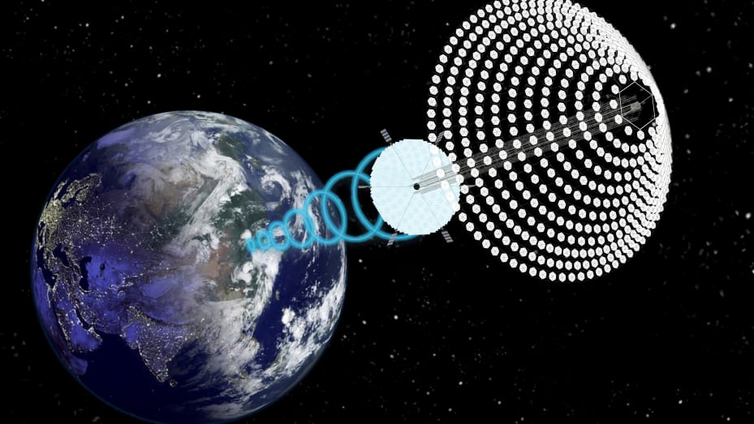
A concept designed by aerospace engineer John Mankins for a space-based solar project dubbed SPS-ALPHA. Mankins worked for NASA before returning to the private sector and created several space-based solar concepts at the space agency, from a ‘Solar Clipper’ interplanetary transport vehicle to the ‘SunTower’ space solar power system.
SPS-ALPHA concept & image provided by John C. Mankins
Mankins said this view is becoming quickly outdated due to a dramatic lowering of rocket launch costs through efforts funded by billionaires including Tesla founder Elon Musk’s SpaceX and Amazon founder Jeff Bezos’s Blue Origin. Meanwhile, developments in robotics and modular-manufacturing — being able to produce many small modular pieces to make a whole rather than one huge piece of equipment — could lead to cost-effective ways to construct these projects in orbit without having to build a multi-billion-dollar factory in space. He referenced a major review conducted by the federal government in 1981 that when looked at in today’s dollars would have cost up to $1 trillion to deliver the first kilowatt/hour of solar from space. “The whole program was killed in the U.S.,” he said.
Now the studies conducted on feasibility are decades old and simply no longer relevant to the discussion, Mankins said. “Whenever a gray-haired senior scientist tells you something can be done, they are almost certainly right. When they tell you it can’t be done, he or she may very well be wrong,” he said, referencing an adage by science fiction author Arthur C. Clarke from his famous “three laws.”
“We have had a revolution in robotics, drones and warehouse robots that didn’t exist. Previously, the whole thing had to be built as one huge system, an enormous thing like a aircraft carrier shipyard in space to fabricate one enormous object weighing 10,000 tonnes rather than 10 million small units each weighing a few pounds that can use mass production,” he said. “We no longer need a stupendously huge factory in space and hundreds of astronauts to put it together. The whole world, other than the space program, has moved forward to mass-produced modular network devices. That’s the way you would do it, and it was unthinkable 40 years ago, but suddenly it is physically, technically and economically doable.”
American scientists are tinkering with the idea to this day. A group at the California Institute of Technology claims to have created a prototype that is able to capture and transmit solar energy from space, using light weight tiles, work sponsored by a $17.5 million research agreement with Northrop Grumman. Weight has always been a key issue to resolve because of the cost of rocket launches being based on weight of cargo. Thin film solar panels are lightweight, which reduces launch cost. Though as launch costs come down it may be less of a make-or-break issue. Thin film may also have a structural advantage in space — the lighter weight is no issue in the zero-gravity environment.
Other nations are exploring the concept. In India and in Europe scientists are working on additional concepts for solar based power in space. Japan’s JAXA, an aerospace exploration agency, has been researching how to overcome technological barriers, such as microwave wireless power transmission tech and robotic assembly tech.

The US military has begun exploring the idea
The most important U.S. effort underway today is arguably the one being conducted by the U.S. military, which received $178 million in its current fiscal year to explore space-based solar power.
For the military, space-based solar could solve big issues with delivering power to posts in remote locations, such as in Afghanistan, where getting fuel to a base means driving a truck loaded with flammable gasoline through hostile territory. Solar power beamed from space would also offer bases a new method of powering their operations, recharging the huge battery packs that soldiers carry today because they have so many electronic devices, and could lead to a ramp up in use more electric vehicles. “Anything the military does will push the technology, and CalTech is pushing hard too with the thin film cells, and that work is going well,” Hopkins said.
A Department of Defense spokesman said the DoD routinely conducts research to explore concepts such as space-based solar power, but it did not have details to provide at this time.
One of the concerns that has dogged the concept is the idea that these projects are really clandestine efforts to develop a space-based laser cannon. Mankins said those fears are based in real physics, but not supported by the reality of military equipment monitoring by the world’s powers. High frequency lasers could be concentrated to serve as a weapon, but any equipment with that purpose would be obvious in its construction, and that is construction that is easily monitored from the earth. “If you look at armored vehicles with machine guns versus a Ford F150 pickup, the difference would be discernible from the ground, even if there are some similarities,” Mankins said. “You would see something that looked like a Hubble telescope.”

Risks of solar in space
Hughes said that going into space and intercepting sunlight that would have otherwise gone past the earth can heat up the temperature within our atmosphere, though he added that this effect depend on the size of the solar collector in space.
“If the plan is to capture solar energy in space, that means the total amount of solar energy going into earth goes up, that increases the earth’s temperature,” Hughes said. “Now of course that depends on how much energy is being brought in. It only becomes a problem when the area of the solar connectors in space becomes comparable to the size of earth.”
Mankins said there are significant risks for the planet that need to be considered, including an increase in temperature and unintended consequences for various forms of life. “There is a reason birds like to sit on utility wires.” But it is no different that worries about UV rays, and the concerns are “not known showstoppers.”
He said the length of microwaves being contemplated for these projects do not pose a significant health risk. He also studied the global warming argument in detail and said it is a fact that beaming power from space to the earth will have an impact on surface temperatures. But when you look at how efficient the delivery of solar from space could be versus the addition of more coal-powered, natural gas-fired or diesel power generation, the resulting greenhouse gas emissions are still much lower.
One thing the Chinese are really good at is thinking long-term, unlike U.S. thinking, out 50 years about this stuff. They have no problem thinking like that.
Michael Byers, a professor in the department of political science at University British Columbia Vancouver says the biggest problem for this concept may be a matter of time. Space-based systems might well be possible several decades from now, but Earth-based systems are already catching up to fossil fuels in terms of cost and efficiency. “You can put solar panels just about anywhere. Rooftops are the most obvious location, and in some jurisdictions all new buildings must have solar arrays. Lots of small projects are better than a few big ones, since they provide greater resilience to equipment failures and weather events,” Byers said.
Hopkins said price competition from Earth-based utility generation is a real issue, but not an insurmountable one. As prices fall for solar technology on the ground, they fall for solar that would be used in space as well. And space-based solar — because it can beam electricity anywhere in the world — can take advantage of the big price differential in the utility market.
A space-based solar system can target places like Japan or Hawaii, where electricity prices can be four to five times prices in the mainland U.S. and then can move to lower-cost electricity markets later once the solar project has paid for itself. “That’s the military thinking. The money you are sending to remote military bases can pay for the technology later. There is a return on investment in the future that doesn’t require sending the electricity to Los Angeles today.”
Each morning, the “Beyond the Valley” newsletter brings you all the latest from the vast, dynamic world of tech – outside the Silicon Valley.
But the detractors remains convinced it is an idea that will remain in the world of Asimov’s stories.
“The concept of space solar power is and will remain in the realm of science fiction for a long time, maybe forever. Even if China or any other nation decides to build an SBSP demonstrator, it does not mean that it is a good idea and that it makes economic sense to do so,” L de Weck said.
National Space Society director Hopkins said that kind of thinking — coupled with the U.S. government’s inability to think long-term in its planning — may be the biggest risk of all. He said that current views in the U.S. on the topic tend to fall into one of two camps.
“People in the U.S. tend to look at it as, ‘At least the Chinese are doing it, and if the Chinese are doing it, then we are likely to do it at some point because we don’t want them to lead.’ Others are saying, ‘If they get this right and we don’t, we are in big trouble.’” Hopkins added, “One thing the Chinese are really good at is thinking long-term, unlike U.S. thinking, out 50 years about this stuff. They have no problem thinking like that. When I talk to NASA about anything more than 10 years out, they sort of look up in the air and roll their eyes, and I’m not invited back.”

https://spacenews.com/chinas-super-heavy-rocket-to-construct-space-based-solar-power-station/

China’s super heavy rocket to construct space-based solar power station
by Andrew Jones — June 28, 2021
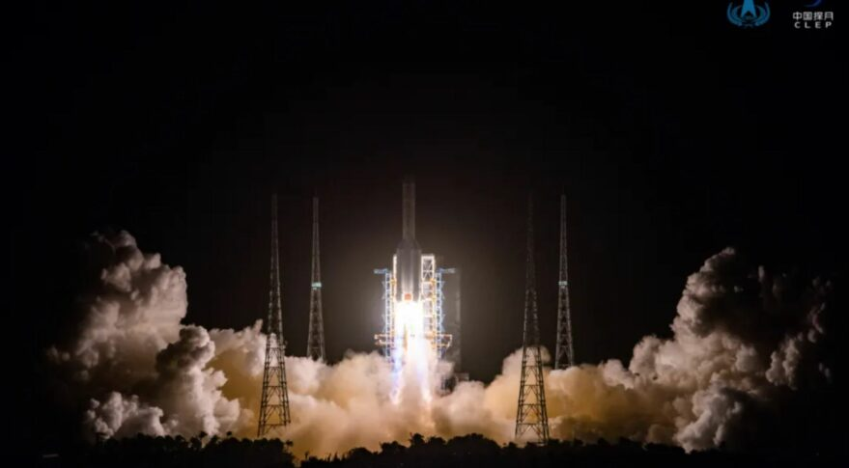Launch of Chang'e-5 atop a Long March 5 rocket, currently China's largest rocket, from Wenchang in November 2020. Credit: CNSA
HELSINKI — China plans to use a new super heavy-lift rocket currently under development to construct a massive space-based solar power station in geostationary orbit.
Numerous launches of the upcoming Long March 9 rocket would be used to construct space-based solar power facilities 35,786 kilometers above the Earth, according to Long Lehao, chief designer of China’s Long March rocket series, speaking during a presentation Thursday in Hong Kong.
The project would aim to establish a large collecting area receiving solar energy near constantly, without the atmosphere or seasonal changes affecting energy levels. Converted energy would be then transmitted to Earth via microwaves or lasers. The project would provide large-scale renewable energy and help tackle energy resource scarcity.
The project, according to Long, would begin with a small-scale electricity generation test in 2022, leading to a megawatt-level power generation facility around 2030.
Commercial, gigawatt-level power generation would be realized by 2050. This would require more than 100 Long March 9 launches and around 10,000 tons of infrastructure, assembled in orbit. The complex project calls for a solar energy collection system with an area on the order of square kilometers and a large microwave power transmission sub-system.
Qi Faren, another senior space figure and chief designer of the Shenzhou spacecraft, also spoke of the complex megaproject and its potential value day earlier.
Both Long and Qi however note major challenges including economic feasibility and manufacturing costs, as well as the efficiency and safety of energy transmission.
Space-based solar power projects have previously been considered by countries including the United States and Japan. China listed space-based solar power as a key research program in 2008, according to Xinhua. The China Academy of Space Technology (CAST) in 2019 began building a test base in Chongqing Municipality for researching high-power wireless energy transmission.

New path for Long March 9?
The launch vehicle slated to do the heavy lifting is the Long March 9. The launcher gained formal government approval this spring, following years of studies and technology development. Yet the design may have seen recent radical changes, according to the presentation from Long.
One slide indicates the old design of the Long March 9—consisting of a 10-meter-diameter core stage with four five-meter-diameter side boosters using 500-ton-thrust, dual-nozzle YF-130 engines—is to be replaced by a vision for a single, 10.6-meter-diameter core powered by a cluster of 16 new, single-nozzle YF-135 engines.
Payload capacity would increase from 140 metric tons to Low Earth orbit (LEO) to 150 tons, from 50 tons to trans-lunar injection (TLI) to 53 tons. A two-stage version would launch to LEO while the three-stage variant would serve higher orbits.
Though not stated, the new engine configuration would also be expected to be more amenable to first stage reusability. Such capabilities would be required for the space-based solar power project.
Long’s presentation also touched on another heavy-lift rocket for launching crew, using the name Long March 5-DY. Two launches of the three-core launcher could be used to get astronauts to the moon earlier than 2030, using a previously presented lunar orbit rendezvous mission profile.
Other developments relayed by Long include plans for space planes and for a first recovery attempt of the new Long March 8 in 2022. First stage hop tests are expected in 2021, according to prior releases.

