How to kill oil spill (8 September 2010)


http://www.bbc.co.uk/news/science-environment-11229405

Using a scale model, Jem Stansfield of BBC TV's Bang Goes the Theory shows how the BP oil spill in the Gulf of Mexico happened and demonstrates the different techniques being used to try to stop the leak.

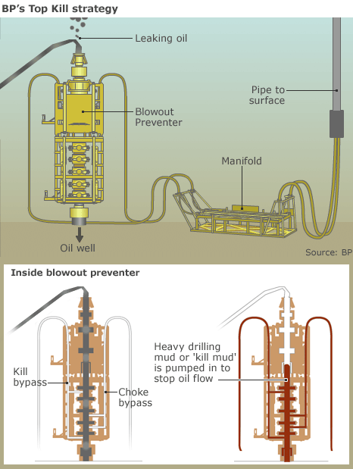
What we’ve got here is an oil rig and it’s positioned over above a thousand meters of sea water and a couple of miles of rock down to an enormous oil reservoir. And that reservoir is on a huge pressure. And if I was wreckless enough to go drilling wheeling kneeling into that oil reservoir, we’ve pretty much guaranteed a disaster. So what do I do ? I use this : mud.

It’s mainly a clay called bentonite mixed with water. This lot has a specific gravity of 1.75 , which means it’s nearly twice as dense as oil.

That’s the drill hole full of mud, and if I’ve got my sums right, when I burst through into that oil reservoir, the weight of mud in this pipe should exactly balance the force of the oil trying to squirt up. And…

We’re definitely through there, I can feel it but it’s balancing. There’s no oil coming up, yet the pressure of the oil should be sufficient to squirt it straight at the top. It’s totally being held just by the weight of the mud in the tube. This simple system is what keeps thousands and thousands of oil wells around the world from blowing out.

But for whatever reason, its hydrostatistic balance as it called was lost onboard deepwater Horizon. Oil and methane burst out of the rig and exploded killing 11 and causing the biggest oil spill in the US history.

So what do you do once an oil rig like this goes out of control ? The first thing you try is pumping heavy mud back in there. The idea is to increase the weight of the mud in the tube and fight the enormous pressure at the reservoir pushing oil up. BP tried that in May, it didn’t work. The next thing to try is to cap the well. It’s like putting a massive steel cork in the top top of it. But it is like a massive steel cork and that’s only a temporary measure. The one way to finish the well completely is to drill a relief well.

And this is how it’s done : a second well is drilled also called relief well, but this one goes down and across through a few thousand meters of rock. But that is an astonishing engineering feat, because not only you’re drilling sideways, you’re trying to hit something that is no bigger than a lamp post.

And that’s through. For now what happens is that mud is forced down to that as it goes into the original well the oil pushes it up and so the original well is full of mud. Then the weight of that mud prevents any more oil from escaping the reservoir. If they manage to achieve this in the Gulf of Mexico, they will then replace the mud with concrete and then kill the whole well off forever.

exploit, prouesse

